
Core Habits - Honour (Romans 12:9-21)
Senior Pastor Chris Kam

Love must be sincere. Hate what is evil; cling to what is good. Be devoted to one another in love. Honour one another above yourselves. Never be lacking in zeal, but keep your spiritual fervour, serving the Lord. Be joyful in hope, patient in affliction, faithful in prayer. Share with the Lord’s people who are in need. Practise hospitality. Bless those who persecute you; bless and do not curse. Rejoice with those who rejoice; mourn with those who mourn. Live in harmony with one another. Do not be proud, but be willing to associate with people of low position. Do not be conceited.
Do not repay anyone evil for evil. Be careful to do what is right in the eyes of everyone. If it is possible, as far as it depends on you, live at peace with everyone. Do not take revenge, my dear friends, but leave room for God’s wrath, for it is written: ‘It is mine to avenge; I will repay,’ says the Lord.
On the contrary: “If your enemy is hungry, feed him; if he is thirsty, give him something to drink. In doing this, you will heap burning coals on his head.” Do not be overcome by evil, but overcome evil with good. (Romans 12:9-21)

Introduction
DUMC’s theme for 2017 is to Step Out, and so far, 3 Big Ideas have been laid out. They are:
#1: Love God, Serve People, Make Disciples
#2: Make Disciples towards Christlikeness
#3: Church is not a place we go to but something we become.
Through observation, there are traits and habits that the members of DUMC do that are distinct in doing life with one another, such as praying on the spot for one another’s needs; or that 70% of the people who attend DUMC are connected in cell groups. Other good habits include spiritual ones such as doing our quiet time, attending church and regularly, serving consistently and being thankful.

“A new command I give you: Love one another. As I have loved you, so you must love one another. By this everyone will know that you are my disciples, if you love one another.” (John 13:24-35)
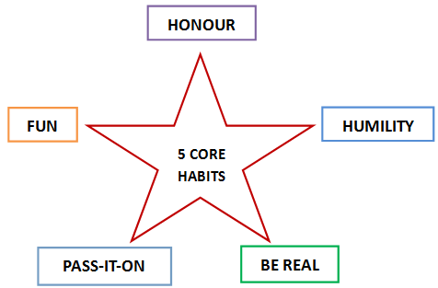
It is not easy to love another, but it is something that we need to do over and over again, so that it becomes a habit. Then, people will recognize us for the trait.
What then makes DUMC unique?
DUMC aims to incorporate 5 core habits among its members:
The first core value is honour. Honour is a practice of giving due / worth / value / esteem to one another. If we honour God, we will honour people (our family, colleagues, community, etc.)


Big Idea: Honour begins with God and is reflected through us.

Honour begins with God
Love must be sincere. Hate what is evil; cling to what is good. (Romans 12:9)
Love here refers to the Greek word “agápē” which means unconditional. It is a love that is a supernatural act, and comes from God himself.

And hope does not put us to shame, because God’s love has been poured out into our hearts through the Holy Spirit, who has been given to us. (Romans 5:5)
The foundation of honour comes from God. It is through our Trinitarian God that we need to tap into to learn about honour. Just as Jesus honours God the Father and the Holy Spirit in the trinity, we should also honour one another too. We can honour others by loving and serving them.

Honour reflected through us
Be devoted to one another in love. Honour one another above yourselves. (Romans 12:10)
In the world system, we expect people to honour us. In the Bible, however, it says “honour above yourself”. It is counter-cultural.
The opposite of honour is shame. Note the differences.
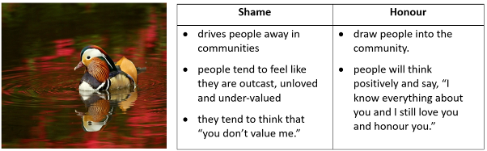
The depth of how much someone honours you is the depth of your honour towards others.
Honour can be reflected in two ways:

(a) Honour in words
Love one another with brotherly affection. Outdo one another in showing honour.” (Romans 12:10, ESV)
In this version, the emphasized word is “outdo” - it is like a healthy competition for us to give way to others. For example, saying to another person, “You first.”

The tongue has the power of life and death, and those who love it will eat its fruit. (Proverbs 18:21)
Are we quick with our words? Would you regret what you say?
What we say can either kill or give life to another person. So, we should not be flippant with our words. We have to learn to pause and think if what we say to another person would bring life upon people, and not of destruction.

“All kinds of animals, birds, reptiles and sea creatures are being tamed and have been tamed by mankind, but no human being can tame the tongue. It is a restless evil, full of deadly poison. With the tongue we praise our Lord and Father, and with it we curse human beings, who have been made in God’s likeness. (James 3:7-9)

Why should we honour others with our words:
- To edify - to build up a person; not to tear them down. Listen to know about one’s needs before you start to talk. Learn to have a right relationship with one another.
- Do not let any unwholesome talk come out of your mouths, but only what is helpful for building others up according to their needs, that it may benefit those who listen. (Ephesians 4:29)
- To encourage - to acknowledge what we are thankful for; to say something good to one another at the appropriate time and place. Don’t look at the fault of others. Encourage those in ministry.
- Hate what is evil; cling to what is good. (Romans 12:9b)
- Be joyful in hope, patient in affliction, faithful in prayer. (Romans 12:12)
- To ease - to bring comfort to others with our “I am with you” presence and words. Be mindful.
- Rejoice with those who rejoice; mourn with those who mourn. (Romans 12:15)


(b) Honour in deeds
- Honour one another
- Share with the Lord’s people who are in need. Practice hospitality. (Romans 12:13)
We can show good hospitality by inviting others into our lives and opening our homes to people who are in need and spending time with them.
- Rejoice with those who rejoice; mourn with those who mourn. (Romans 12:15)
In a time of one’s greatest need, we can (as a Cell Group) surround and support them.
- Live in harmony with one another. Do not be proud, but be willing to associate with people of low position. Do not be conceited. (Romans 12:15)
God is encouraging us not just to associate the people in high positions but also the poor, the widows, orphans and the destitute.
- Honour the poor and the destitute
- What good is it, my brothers and sisters, if someone claims to have faith but has no deeds? Can such faith save them? Suppose a brother or a sister is without clothes and daily food. If one of you says to them, “Go in peace; keep warm and well fed,” but does nothing about their physical needs, what good is it? In the same way, faith by itself, if it is not accompanied by action, is dead. (James 2:14-17)
The destitute are people who are so poor that they need others’ intervention to get out of their poverty. Ask God to open your eyes to see that there are many people out there in need.
- Love your enemies
- Do not take revenge, my dear friends, but leave room for God’s wrath, for it is written: “It is mine to avenge; I will repay, ”says the Lord. On the contrary: “If your enemy is hungry, feed him; if he is thirsty, give him something to drink. In doing this, you will heap burning coals on his head.” Do not be overcome by evil, but overcome evil with good. (Romans 12:19-21)
(Note: To heap burning coals: In the Ancient Egypt, when someone has repented, he will carry a pan of burning coals and walk around saying “I repent. I repent.”)
Remember that the real enemy is the devil and his demons, not the people around us.
Recognize the depth of God’s love and amazing grace for us, it is possible for us to
honour others.

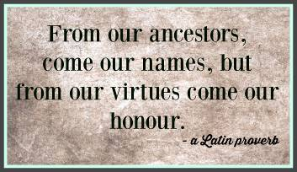

Sermon summary contributed by Wendy ML
Prayer points contributed by Anthea Tan


SERMON: Core Habits - Honour
Pray:
- We will cultivate a habit of honouring God and people, to learn to honour with our words and deeds.
- We will learn to live in harmony with one another, and we will not be proud or conceited, but be willing to associate with people of low position.
- Our words will be used to lift up, encourage, edify and to comfort instead of to tear down and destroy.
- We will learn to love our enemies the way God wants us to, and not be overcome by evil, but to overcome evil with good.
Be devoted to one another in love. Honour one another above yourselves. (Romans 12:10)

MINISTRIES & EVENTS: W2W Moments
W2W Moments are starting their Bible Study sessions next weekend, on 11 February. W2W Moments are sharing sessions that consists of groups of women who gather together to study God’s Word.
Pray:
- That God will prepare the hearts of the participants to hear and receive from Him.
- The facilitators will be prepared and strengthened to lead the Bible Study sessions.
- There will be unity and a good bond among the women in the groups, and they will be an encouragement to one another.
- God will raise up godly women of Christ who will shine His light in the world around them.
The light shines in the darkness, and the darkness has not overcome it (John 1:5)
MALAYSIA MY NATION: Rising Crime Rates
Crime rates such as snatch theft, robbery and so on have been rampant. These are desperate times and there are many individuals who will take desperate measures to get what they want.
Pray:
- God’s divine protection to be upon the people.
- People will have discernment in all situations and be guarded at all times.
- God will convict and instil a fear of the Lord in the hearts of all people so that they will not think of committing sin.
- The authorities will be wise and proactive in combating crimes in the country.
The hand of our God was on us, and he protected us from enemies and bandits along the way. (Ezra 8:31)
A TRANSFORMED WORLD: Persecuted Church
A pastor in eastern Uganda and eight other Christians are missing two weeks after a Muslim mob attacked a church prayer meeting, locked the congregation in, beat several members and raped 15 women, sources said. The approximately 90 Muslims broke into the evening prayer meeting of Katira Church of Uganda, in Katira village, Budaka District at about 8:30 p.m. on Jan. 15 and beat them with clubs and sticks, area sources said. Previously Muslims had only thrown stones at the roof of the church building to disrupt church services of the 500-member congregation, villagers said.
Pray:
- God to intervene in the situation and the hostages will be rescued and unharmed.
- God’s comfort and restoration for the victims, especially the women who were raped.
- This incident will not shake the faith of the church, but the church will rise up and grow stronger in their faith.
- God will convict the attackers of their sin and turn their hearts to Him, that they will love and fear Him.
Blessed are those who are persecuted because of righteousness, for theirs is the kingdom of heaven. (Matthew 5:10)

