Following Christ = Making Disciples: Jesus and me, and this thing called community
Pastor Mike Ngui

So Christ himself gave the apostles, the prophets, the evangelists, the pastors and teachers, to equip his people for works of service, so that the body of Christ may be built up until we all reach unity in the faith and in the knowledge of the Son of God and become mature, attaining to the whole measure of the fullness of Christ. Then we will no longer be infants, tossed back and forth by the waves, and blown here and there by every wind of teaching and by the cunning and craftiness of people in their deceitful scheming. Instead, speaking the truth in love, we will grow to become in every respect the mature body of him who is the head, that is, Christ. From him the whole body, joined and held together by every supporting ligament, grows and builds itself up in love, as each part does its work. (Ephesians 4:11-16)

Introduction
The goal of the body of Christ is maturity, towards the likeness in Christ. That is why God gives gifts to the church. Gifts such as apostles, prophets, evangelists, pastors and teachers. The point is not what the gifts are, but what they are for - that the body of Christ may mature.

Paul himself said. “This is what I strive to do… “that we may present everyone mature in Christ.” (Colossians 1: 28, 29)

What does the church have to do with community? How important and vital is the church or cell group? Isn’t discipleship all about me? What is this thing called church and the community? Is it an obligation or necessity to be part of a local church or is it optional? Is it vital and integral in following Christ? What have non-faith communities got to do with our following Jesus Christ?
The Big Idea:
We cannot know Christ and become like Him, by ourselves. Christian discipleship and maturity is forged in community with others.

We are all in community - by design or by default.
A community consists of a network of relationships which are formed. All of us are in communities, such a marriages (community of two), or family, friends, at school, college, or at the marketplace.

What about the spiritual community? Well, it is firstly by God’s design.

“... we were all baptized into one body—Jews or Greeks, slaves or free.” (1 Corinthians 12:13, ESV)
The local church is the only community place that is explicitly described in the bible that will help us grow towards Christlikeness and maturity.

Every community embroils us into the messiness of real people
Be it in a marriage, a business deal or family relationships, things may not be as neat as we like them to be. Real people are messy, fake ones are neat.

It is true that in every community: When you love them, they hurt and hate you. When you trust them, they disappoint you. When you care for them, they end up irritating you. When you give to them, they will still find reasons to complain. Why? Because people are imperfect, sinful. We are all sinful. Our emotions, actions and reaction get messy. Yet, we are called to honour, love, serve and respect each other, care for and forgive.

Even Jesus had all kinds of messiness - people asking and waiting for the next free meal because He had fed 5,000 people; people turned away when they did not like a message; His disciples jostled for position and power.

Our communities are imperfect - spoiled and tarnished by sin. It is a default situation.
All sin results in isolation. Sin does n0t just cut us from God, it also isolates us from each other.
On the other hand, forgiveness results in restoration. Forgiveness brings communities back together again. Forgiveness heals broken relationships.

Sin destroys and damages community. Forgiveness restores community. The glory of the gospel ultimately brings healing and restoration not only to our relationship with God but with the human community. It allows and gives us the capacity to be restored and reconciled with each other. Genuine healing, forgiveness and acceptance, through experiencing unconditional love received by faith, will be granted to us in grace.

A Christian has the potential to bring healing to the community that he / she is in, whether it is a faith community or otherwise. This is because a Christian has experienced reconciliation and forgiveness personally, thus he or she is in a place to bring healing and restoration into the community.

It is only the church of Jesus Christ that knows that there is the unconditional love and unconditional forgiveness and therefore, can bring about reconciliation. A community inhabited by a disciple of Christ has the potential of being restored and healed. A community of Christians (the church) has the greatest potential to experience true and authentic community as we are able to love and accept one another unconditionally.

It is a potential because in every community, we still have to choose to:
- Be “present” - in heart & mind and not just merely in the body.
- Contribute / give - and not just consume.
- Protect, patch-up and persist especially when things are not well.

If we give up or bail out, we basically put an end to the community.

Every community gives us opportunity to become more like Christ
“You are the light of the world… Let your light shine before others, that they may see your good deeds and glorify your Father in heaven.” (Matthew 5:14-16)
The non-faith communities are watching us. Our actions and our words, “say Christ” to them.

The Christian community is explicitly by God’s design intended to help, build, support, edify, nurture and encourage us in our growth towards Christlikeness.

And let us consider how we may spur one another on toward love and good deeds, not giving up meeting together, as some are in the habit of doing, but encouraging one another—and all the more as you see the Day approaching. (Hebrews 10:24, 25)

Whose responsibility is it to spur and encourage one another? It is up to us, for our brother.
The Holy Spirit will give us feedback to us on where we need to go. He will work to shape us regardless the community that we are in.

Every community needs us to choose to be like Christ
“You are the salt of the earth” (Matthew 5:13a)
“You are the light of the world.” (Matthew 5:14a)
Salt and light were very valuable in the ancient world. Salt was precious.
Salt adds value to the world (flavour) while light shines in darkness.
We are to be salt and light especially to the non-faith communities.

In a faith community - when we are “not up to scratch” - it will be an opportunity for our growth. Pastor CB Samuel said that it was in the wilderness, that God forges characters of the people. When there are times when things are “not life-giving” - we can choose to give life to the situation.

What does it mean, to choose to be like Christ in our communities?
We have to exercise choice and ask ourselves:
- Do we choose to be “present” in heart and mind?
- Do we choose to contribute, to the welfare and growth of the other?
- Do we choose to protect, patch up and persist?
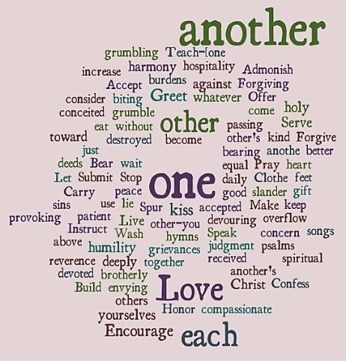

Conclusion
In the New Testament, there are 59 verses with the phrase “One Another”. 17 times, Love appeared. 1 Corinthians 12-14 talks about gifts to help us grow, but without love, those gifts don’t help.

So, do we enter our communities with love? Are we engaged in our community in love? It is only in love, that the communities will experience Christ for us. In a Christian community, it is the only way that we will experience Christlikeness as we grow in Christlikeness.

Communities are indispensable in the process of us becoming more like Christ. Knowing that we want to be more like Christ, we need our communities so that we may accomplish that. We need to be more Christ-like, especially in the non-Christian communities because for them to experience Christ, we who are in those communities, need to grow to be more like Christ. We are the salt of the earth and the light of the world.

We need to choose to be like Christ and bring Christ into the community, then our communities will grow. And will become more mature and will grant opportunity to others to mature as well.

Community is indispensable to our discipleship. We cannot become more like Christ without us being in our communities consciously, mindfully, fully present, and seeking to be more like Christ in each of these communities.

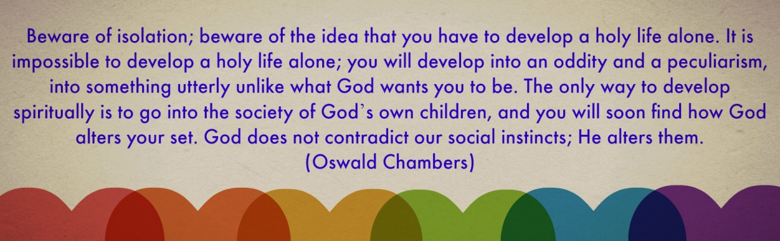

Sermon summary contributed Wendy ML.
Prayer Points by Abbey Thangiah.
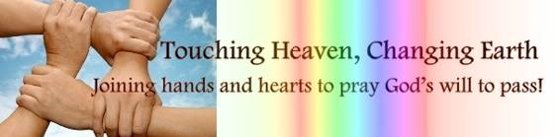

SERMON: Jesus and Me and This Thing Called Community
Pray:
- We will accept that the community is made of imperfect people.
- We will continue to care, pray, forgive and put up with one another.
- We will forgive one another to restore the community.
- We will accept the unconditional love God has given us so that we will change and transform the communities around us.
- We will proactively choose to be present, contribute and patch up our communities.
Then we will no longer be infants, tossed back and forth by the waves, and blown here and there by every wind of teaching and by the cunning and craftiness of people in their deceitful scheming. Instead, speaking the truth in love, we will grow to become in every respect the mature body of him who is the head, that is, Christ. (Ephesians 4:14-15)

MINISTRIES & EVENTS: Submit or Not by CNBM
A seminar that looks at the responsibilities of those who govern and those who are governed. On Saturday, June 17th.
Pray:
- Spiritual protection for the administration, venue, speakers and the organization team.
- Many from church and outside church will turn out for the plenary and breakout sessions.
- People will come with an open heart and mind to learn about when to submit.
- God will raise more nation builders to serve in the CNBM ministry.
- God’s name will be glorified and his power will be visible to all those who came.
Let everyone be subject to the governing authorities, for there is no authority except that which God has established. The authorities that exist have been established by God. (Romans 13:1)
MALAYSIA MY NATION: NATIONAL POLICE FORCE
IPOH: A major reshuffle in Bukit Aman is set to take place following the arrests of several top policemen in the Narcotics Crime Investigation Department (NCID). Khalid also said about 20 policemen from the NCID have been transferred out as part of its internal reshuffle. "Changes in personnel at the bottom level have taken place. “There’s still a bit more (movement) as there are separate units under the department," he said, adding that reshuffling in the police force was a common practice but there would also be some extraordinary circumstances. (thestar.com)
Pray:
- Fair and just policing in this country.
- This reshuffling will create a positive impact to the governance of the police force.
- The police and other departments will be work together.
- Transparent handling of the various cases fairly and justly.
- The media will be more mature in telling news without any biases.
- God will raise more Christians in the police force.
Remind them to be submissive to rulers and authorities, to be obedient, to be ready for every good work, to speak evil of no one, to avoid quarreling, to be gentle, and to show perfect courtesy toward all people. (Titus 3:1-2)

A TRANSFORMED WORLD: UK Elections
The Democratic Unionist Party says it has had "positive talks" over a "confidence and supply" deal to support a Conservative government. Theresa May was left eight seats short of an overall majority in the general election, while the DUP won 10 seats. Tory chief whip Gavin Williamson went to Belfast on Saturday for talks with the Northern Irish party. The DUP said talks would continue next week to "work on the details" and "reach agreement”. A "confidence and supply" deal is not a full coalition, but an agreement which sees the smaller party support the larger one in key votes such as on the Budget. Any agreement will come into force when Parliament returns next week
Pray:
- The political parties will put the people’s interest first.
- A stable UK during elections and Brexit.
- God’s justice and fairness will prevail during this time of turmoil.
- Media will be wise to separate rumours from the truth and report responsibly.
But avoid foolish controversies, genealogies, dissensions, and quarrels about the law, for they are unprofitable and worthless. (Titus 3:9)

