
Living Christ Out in Community: Act Justly
Dr Bill Wilson

Saturday Celebration
In the year that King Uzziah died I saw the Lord sitting upon a throne, high and lifted up; and the train of his robe filled the temple. And I heard the voice of the Lord saying, “Whom shall I send, and who will go for us?” Then I said, “Here I am! Send me (Isaiah 6:1, 8)

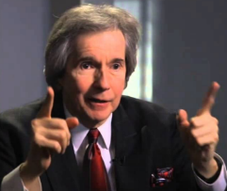
Introduction
Dr. Bill Wilson has just finished a PhD in the University of Wales. He has gone through many things in life. He hoped he would be able to communicate to us in a way that would force us to think.
Dr. Wilson’s mother left him on the street when he was 12 years old. He was left there for 3 days. One person stopped to ask him if he was OK, an ordinary Christian whose own child was dying of leukemia in the hospital. This man chose to stop and check out the kid that nobody wanted. The man got him fed and then arranged for Dr. Wilson to go to a Sunday School camp where he gave his life to Jesus. There are many children out there waiting for an ordinary Christian to choose to stop and pick them up.

The Need is the Call
Dr. Wilson was being interviewed by BBC. The presenter asked him how is it that at this age, his vision for the ministry is even greater than before.
How could some Christians catch the vision but not others? We see the difference when someone sees something and does something about it.
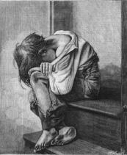
The man who picked up Dr. Wilson when he was on the street did not need a PhD to see the need. He did not have to pray on what he needed to do. That is the call that God puts in front of him.
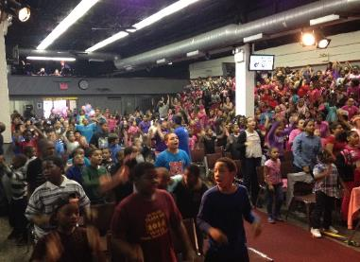

Big doors open on very small hinges. It’s the little things that God put in front of us every day. If we are astute enough to see it and do something about it, it puts something in motion in our lives. Often, we want to wait for the big things. Dr. Wilson has observed all over the world that it is the small things that we see and respond to that makes a difference.
Dr. Wilson’s Metro World Child is a Sunday School with 183,000 children meeting every week. The number will soon surpass 200,000. All this was because an ordinary Christian saw a kid on the street that nobody wanted and decided to pick him up, fed him and sent him to a camp. His child was in the hospital. He had every reason to walk on without doing anything. Still, in the midst of his personal struggle, he chose to stop for boy.
The CNN presenter wondered how Dr. Wilson could have an even greater vision now. How is it that he is still driving bus carrying children to Sunday school?
We often mistakenly think that only the chosen few receive great visions. We think that ordinary folks do not get these great visions.
Dr. Wilson was speaking at a convention and met Dr. Billy Graham. He was as ordinary as the next person. Yet, he is an evangelist with such great vision.
How can ordinary people can see the need, heed the call and put something in motion?

The Process of Getting the Visions

Upward Vision
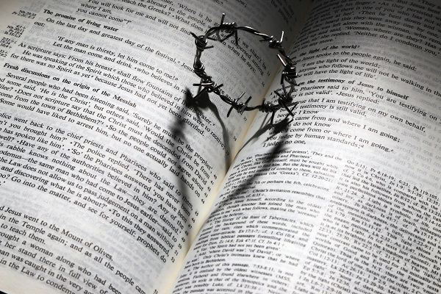
When we discuss visions, we normally look at verse 8. However, Dr. Wilson wanted us to look at verse 1.
In the year that King Uzziah died I saw the Lord sitting upon a throne, high and lifted up; and the train of his robe filled the temple. (Isaiah 6:1)
Could it be that the king must die before the King can be recognized? Sometimes, we need to think who is the king in our lives.
The upward vision allows us to see God for who He is, the reality of the Cross. The upward vision forces you have an inward vision.

Inward Vision

The inward vision makes us see us for who we are honestly and make the necessary changes. We will be willing to make the changes that God wants us to make. When we have an upward vision and an inward vision, then only can we have an outward vision.

Outward Vision
When we have an outward vision, we start to see things differently. We begin to see the child differently. We see people differently. And we can respond to the call.
And I heard the voice of the Lord saying, “Whom shall I send, and who will go for us?” Then I said, “Here I am! Send me. (Isaiah 6:8)

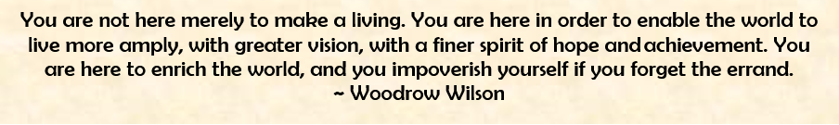
Saturday sermon summary by Loong


Living Christ Out in the Community: Act Justly
Dr. Bill Wilson
Sunday Celebration

The tribes of Israel sent messengers throughout the tribe of Benjamin, saying, “What about this awful crime that was committed among you? Now turn those wicked men of Gibeah over to us so that we may put them to death and purge the evil from Israel.”
But the Benjamites would not listen to their fellow Israelites. From their towns they came together at Gibeah to fight against the Israelites. At once the Benjamites mobilized twenty-six thousand swordsmen from their towns, in addition to seven hundred able young men from those living in Gibeah. Among all these soldiers there were seven hundred select troops who were left-handed, each of whom could sling a stone at a hair and not miss. (Judges 20: 12-16)

Introduction
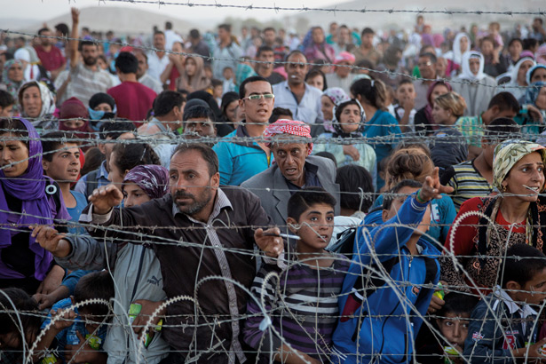
Pastor Bill Wilson lives in two worlds. On one end, he lives the ‘perfect” Sunday life where he goes around the nice places of the world preaching, teaching and appearing on television. On other days, he is on his own in dangerous parts of the world risking his life in crises and wars to reach out to the children and the disadvantaged. He is currently planning a trip to Syria where he will be dropped off in a location. Three miles on one end is a refugee camp and four miles on the other end is the ISIS training camps.

It was better when he was younger but nowadays he does not care what happens to his life. His mind is focused on the work God has set him to do and dying is the least of his problems.

The need is the call
When Pastor Bill Wilson was 12, his mother just told him “I will be back” and just left. He just sat there for three hours. The only person who stopped was a Christian whose child was dying of leukemia in the hospital. He looked at Bill and asked "Are you okay?". Three days and no one cared. Less than five hours later, he was on a van heading to a Sunday School camp. It was his first time in Sunday School and church. All it took was someone to care and ask "Are you okay?" and do something about it. The need is the call. This is missions.

Why do Christians quit?
Pastor Bill was invited as a speaker at the Southern Baptist Convention at Atlanta. He was showing slides and sharing about the unusual things Metro does. They have Sunday school six times a week. The committee is a bunch of unwilling people called to do the unnecessary. The committee left him alone in a room all by himself.

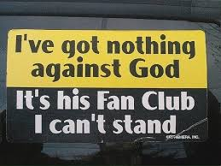
He ended up noticing a cabinet and started browsing the files, especially the one marked. 'Confidential'. It was a five-year study on why the pastors, management and the members of the church leave the Baptist organization.
The United State loses about 1000 preachers a month. The God who made the heavens and the earth called and you just quit because you got offended? This is not acceptable.
Christians leave because of a struggle. It does not matter what the struggle is. It also doesn’t matter whether you are the pastor or the member. It goes across all levels. They continue struggling and getting through and through. In the end, there will be "the straw that breaks the camel's back".


Are you Chosen?
In Judges 20:14, they were preparing for a critical and pivotal battle. They were being prepped and psyched for battle. Out of the twenty-six thousand men who came, only 700 were chosen.
They were not randomly chosen. In Hebrew, being chosen is to be handpicked for a specific reason. Only 9% of the world are left handed at a given time. The future of the nation was in the hands of these 700 men. Why were they chosen? This question bothered Pastor Bill for a long time.
Pastor Bill did his PhD in Wales. He was interested of the preachers of the 1700’s and 1800's because they were historians of their time and looked at things differently. He was browsing books using a torchlight at the basement of a small bookstore in Wales. One of the books was a not so famous commentary by a pastor and that is where he found his answer.
The 700 were chosen because they were no longer right handed. This meant that at some point during the war, they could not use their right hand anymore because they might have lost fingers, arm or loss of motor function of their right hand. They were given a choice to go home or to continue fighting.
If they chose to stay, they had to re-train the left hand. Using the left hand to write is clumsy. They have trained the left hand to the point where they could sling a stone and not miss a horse hair hanging from a tree 30 or 40 yards away. They trained to the point the left hand was as good as the right hand.
The soldiers had a chance to go home but they did not. Instead they continued to serve and fight.
There are groups of people who used to serve God at one point or the other but quit because they got into a fight, got depressed, down or any other reason where they just gave up. These 700 should have quit but they chose to take the thing that stops them and make it better.
Pastor Bill had a hairline cracks in the bone below his knuckles. Usually those in fights have the cracks at the knuckles. Then he realized that he has been using the hands to knock on doors for the past 50 years. His physiotherapist advised him against knocking doors but he is willing to use his other hand for the next 50 years. This is the attitude we should have.

Conclusion
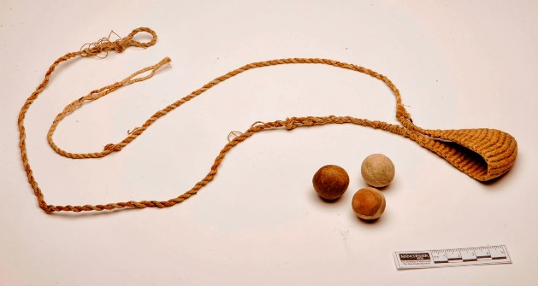
There are three things we can conclude from this.
If your right hand is not wounded? be grateful.
The time is coming when you will be going through fights or when people will disappoint you or just ditch you in the streets. Be prepared for it.
When (not if) you get wounded, you will have the choice to stay or to go home.
Pastor Bill has so many injuries from his head to toe. He has steel plates in his body. Part of his face and jaw was reconstructed. He could have gone home at any time. The doctors predicted that he would not talk anymore but he is still preaching and sharing Gods love.
If you choose to stay, you are qualified to be in God's chosen army.
No matter what the devil throws at you, be ready because you have chosen to stay. God uses wounded people like the 700 because he knows you did not quit.
Sunday sermon summary by Abbey Thangiah.

