
I Love My Church Part IV: Celebrating Jesus
Founding Senior Pastor, Dato’ Dr Daniel Ho
"Consequently, you are no longer foreigners and strangers, but fellow citizens with God’s people and also members of his household, built on the foundation of the apostles and prophets, with Christ Jesus himself as the chief cornerstone. In him the whole building is joined together and rises to become a holy temple in the Lord. And in him you too are being built together to become a dwelling in which God lives by his Spirit." (Ephesians 2:19-22)

Introduction
We should honour Jesus because He came and died for the church. At the heart of it all, the church is about Jesus.

The church is about Jesus

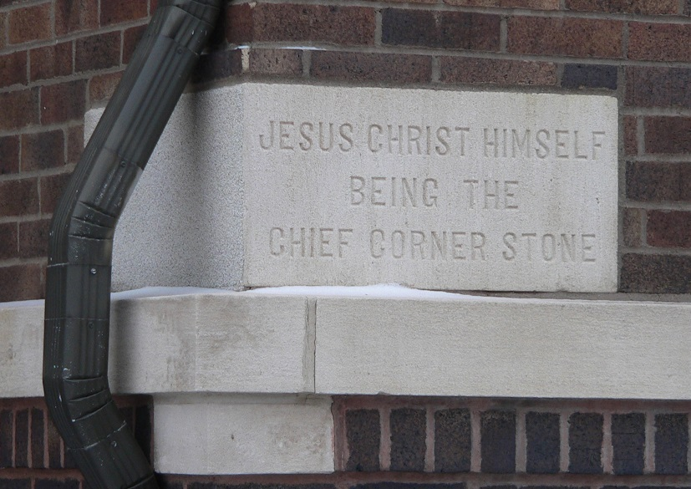
He is the chief cornerstone / foundation stone / capstone.
Consequently, you are no longer foreigners and strangers, but fellow citizens with God’s people and also members of his household, built on the foundation of the apostles and prophets, with Christ Jesus himself as the chief cornerstone. (Ephesians 2:19,20)
- We are part of God’s kingdom / household and a part of the family of God
- It is on Him and in Him that the church is built and so we should gather together to honour Him.

We must build everything around Jesus
And in him you too are being built together to become a dwelling in which God lives by his Spirit. (Ephesians 2:22)
- It is in Him that everything must revolve.
- Don’t build a church or ministry around personalities or people no matter how gifted or charismatic that person may be. Otherwise, the church or ministry will fall apart. The church or ministry should be able to continue even after the founders or seniors have left, moved on or retired.
- We should always look to depend on Jesus. It shouldn’t matter at all when we are not around.

We are to lift up Jesus as the holy temple of God
In him the whole building is joined together and rises to become a holy temple in the Lord. (Ephesians 2:21)
- Because we are the temple of God or the church.
- The temple is a place where we worship our King Jesus. It is also our body where the Holy Spirit dwells in
“And I, when I am lifted up from the earth, will draw all people to myself.” (John 12:32)
- God may draw people to him through his power, grace and presence, such as a touch from the Holy Spirit or even healing during worship.

The Church is about purity and Jesus’ power

Jesus loved the Church by sacrificing Himself to make her pure
Husbands, love your wives, just as Christ loved the church and gave himself up for her to make her holy, cleansing her by the washing with water through the word, and to present her to himself as a radiant church, without stain or wrinkle or any other blemish, but holy and blameless. (Ephesians 5:25-27)
- The church should have a strong emphasis on moral standards. It is burdened with the need for right living. When a church is living right, it (and the people) will be blessed.
- Jesus works to perfect us. He tackles our mistakes and stubbornness, and show us when we are wrong that we may repent and seek his forgiveness.
- Jesus paid a huge price by dying on the cross for us.


Jesus unleashes His power in building His Church
“And I tell you that you are Peter, and on this rock I will build my church, and the gates of Hades will not overcome it.” (Matthew 16:18)
- Jesus himself was involved in building the church.
- Even the opposition or the gates of hell cannot hinder the church from growing.
- For example, China has the fastest growing rate of believers. The latest statistics show that 3 million Iranians have put their faith in Christ.
- Do not waste the opportunity to serve in church. Do not waste or squander your life. Instead go for it.

The Church therefore is unstoppable.
- It will march on, no matter the law, persecution, torture, obstruction, pressure, imprisonment that may befall a church or the people.
- People are spiritual beings that need to be satisfied by God himself. No materialistic circumstances or things can fill that void. To know who you are, you need to know God.

The Church must take her character, message and power into the world
We must take Jesus out of the four walls of the church. Do not keep him to yourself. Take the message of Jesus out to the world.

A character of holiness and humility nobody can object nor refuse.

- Jesus did not come to make you happy. He came to make you holy. You can only be happy when you are holy. You can never be happy if you are unholy. Happiness is a product of holiness. So, we should pursue holiness, not happiness.
- You are unholy when you have compromises in your life. You will feel miserable and ridden with guilt, have no peace nor joy, and be self-deceived. Your conscience will eventually reveal to you what a hypocrite you are.
- An epitome of a holy person is Mother Theresa. She carried an aura that no one could stop nor resist her. She lived her whole life of servanthood for the poor and the marginalized.

A message of salvation and hope nobody can offer
- Only Jesus provides and gives hope to the many people who are looking for hope and are struggling in their lives
- Make a difference in someone’s life.

The power of Jesus nobody can resist.
- It can change and transform nations.
- “God didn’t just change me. He also changed a family, a community, a nation.” (Sek Sarouen, from International Justice Mission, on God’s transformation, during 12 years of battle against the sex trade in Cambodia.)

How do we do this? How do we reach out to the people around us?
- It starts with prayer. Pray daily.
- Build friendships / relationships
- Make time for people, have lunches with our colleagues.
- As we build friendships, we will be able to have deeper conversations with them.
- Show love
- Be radical, different, try new methods - buy lunches for colleagues, offer your parking spot, start a cell group.
- There will never be enough churches being built to reach out to the community around us.
- Turn ordinary conversations into spiritual conversations
- So that our faith comes out
- Start with the positive before moving on to talk about challenges in life (for example, work, health, kids). Give them an opportunity to share about their struggles.
- Extend the invitation / challenge
- Ensure discipleship is carried out right away when a person comes to faith in Christ.

Conclusion
We exist for the world outside. So, be available for God, His kingdom and his people.
As time will pass you by, make every minute count.



Sermon summary contributed Wendy ML.
Prayer pointers contributed by Abbey Thangiah.


SERMON: I Love My Church (Part 4): Celebrating Jesus
Pray:
- Jesus will be the centre of the church and our lives.
- We will always be an example of holiness and humility for others to follow.
- That we will be bold to share our Saviour to others.
- God will help us to turn usual conversations about our work and health to godly conversations.
- God will use us to represent the church with integrity.
Consequently, you are no longer foreigners and strangers, but fellow citizens with God’s people and also members of his household, built on the foundation of the apostles and prophets, with Christ Jesus himself as the chief cornerstone. In him the whole building is joined together and rises to become a holy temple in the Lord. (Ephesians 2: 19-22)

Volunteer Preview 5 November 2017, 1.30 - 3.00 pm
Pray:
- God will raise volunteers to help out in the church.
- God will protect all volunteers from spiritual attacks.
- God will grant patience as the current volunteers train the newer ones.
- For volunteers to have fun while serving the Lord.
- God will bless those who serve him.
“Whoever brings blessing will be enriched, and one who waters will himself be watered.” (Proverbs 11:25)

MALAYSIA MY NATION: Hiring foreign labour
KUALA LUMPUR: Those looking to hire foreign domestic helpers directly should not worry about security, said Datuk Seri Dr Ahmad Zahid Hamidi. The Home Minister said that there are security systems in place such as biometric systems, biomedical systems and security scanning systems to adequately filter any unwanted individuals. "They should not worry as there will be a thorough scanning process," he said to a question of possible security concerns in direct recruitment without the services of agents, such as the possibility of a helper having a criminal record.(thestar.com)
Pray:
- We will treat everybody equally without any stigma to race and religion.
- We will have more confidence towards our foreign labourers and hire them directly.
- Foreign labourers will not take advantage and abuse the privileges they have.
- Malaysian churches will be in the forefront of treating foreign workers fairly.
- Agents and Labourers will work together.
When the LORD will have compassion on Jacob and again choose Israel, and settle them in their own land, then strangers will join them and attach themselves to the house of Jacob. (Isaiah 14:1)
 A TRANSFORMED WORLD: Catalan Independence
Madras (Reuters) - Catalan independence parties are seen as losing their parliamentary majority in an election, according to a poll published on Sunday, though the wafer-thin margin between the two sides predicts a hard-fought campaign to December's ballot.
Pray:
- God will be with the people of Catalan at this time of crisis.
- Protection for the Catalans from all those opposing them.
- That the rest of Spain will treat Catalans with respect.
- The Spanish government will reach a win-win agreement with the Catalans so that Catalan will prosper economically and stay sovereign as they did before.
Comfort, comfort my people ,says your God. (Isaiah 40:1)

