
Studies in the Book of Judges III: Lessons from Jephthah’s Leadership
Founding Senior Pastor, Dato’ Dr Daniel Ho
”Jephthah the Gileadite was a mighty warrior. His father was Gilead; his mother was a prostitute. Gilead's wife also bore him sons, and when they were grown up, they drove Jephthah away. "You are not going to get any inheritance in our family," they said, "because you are the son of another woman." So Jephthah fled from his brothers and settled in the land of Tob, where a group of adventurers gathered around him and followed him. Some time later, when the Ammonites made war on Israel, the elders of Gilead went to get Jephthah from the land of Tob. "Come," they said, "be our commander, so we can fight the Ammonites." Jephthah said to them, "Didn't you hate me and drive me from my father's house? Why do you come to me now, when you're in trouble?" The elders of Gilead said to him, "Nevertheless, we are turning to you now; come with us to fight the Ammonites, and you will be our head over all who live in Gilead." Jephthah answered, "Suppose you take me back to fight the Ammonites and the LORD gives them to me - will I really be your head?" The elders of Gilead replied, "The LORD is our witness; we will certainly do as you say." So Jephthah went with the elders of Gilead, and the people made him head and commander over them. And he repeated all his words before the LORD in Mizpah. (Judges 11:1-11)

Introduction

Every one of us have been hurt before. Whether individually or corporately as a church. So was Jephthah, and yet he led the Gileadites to defeat the Ammonites.

Some lessons that we can learn from Jephthah’s leadership:

Everyone can/should be a leader
So Jephthah fled from his brothers and settled in the land of Tob, where a group of adventurers gathered around him and followed him. (Judges 11:3)
To be a leader, is to be an influencer. Be a leader for good, for God and for His glory. All of us can or should be leaders, because all of us need to lead our own lives. Do not let someone else dictate how to live our lives.

To help grow leaders, DUMC provides EQUIP courses (previously called the School of Leadership)

Irrespective of the background one comes from.
Jephthah the Gileadite was a mighty warrior. His father was Gilead; his mother was a prostitute. (Judges 11:9)
Many of us have a lot of brokenness or pain in our lives. Jephthah’s mother was a prostitute. That was nothing to be proud of, it was a shameful fact in society. In spite of that, God used Jephthah to become a judge over Israel. God can use us too.The world will shun us, but it is not in Scripture. That should be an encouragement to us.

Irrespective of the experience one has gone through in life.
Gilead's wife also bore him sons, and when they were grown up, they drove Jephthah away. "You are woman." (Judges 11:9)

Jephthah was rejected by his own family. It would have been hard, difficult and heart-breaking. It could also be our own experience, where we may have been called useless, good for nothing, told to get out and leave. We may have experienced aches, wounds and hurts in our lives.

Nobody runs away from hurt. We will stop getting hurt when we die. So, what do we do about it?

All that feeling of worthlessness and pain, does not disqualify us from being a leader. We must “DEAL WITH IT”, so that the wounds will not continue to hurt us for life. We must not let them hold us back. When we harbour the past wounds in our life, it will slowly rot and fester in our lives, we may then get crippled and be imprisoned in the future. We will not be able to experience freedom nor joy fully in our lives.

The past can prevent us from living in the future. It would be a terrible way of living and to live with those people. We must learn to let go and forgive.

The importance of dependence upon the Lord in the leadership equation
Jephthah answered, "Suppose you take me back to fight the Ammonites and the LORD gives them to me-will I really be your head?" (Judges 11:9)
In his fight against the Ammonites, Jephthah invoked the name of God. He is conscious of the Lord. It is critical to know that in the heart of leadership, God has to be at the heart of it.

The need to call upon the Lord
So Jephthah went with the elders of Gilead, and the people made him head and commander over them. And he repeated all his words before the LORD in Mizpah. (Judges 11:11)
This it to remind the people that God is the centre of anything that we do or else we would be in trouble. God is a witness to his roles and responsibilities.

The need to look to the Lord at all times
And Jephthah made a vow to the LORD : "If you give the Ammonites into my hands, whatever comes out of the door of my house to meet me when I return in triumph from the Ammonites will be the LORD 's, and I will sacrifice it as a burnt offering." (Judges 11:30,31)

Again, and again, we should look and call to Him.

As we take on the role of leadership, the danger is that we think it is about our own capacity, abilities, and gifted-ness. We start to believe in ourselves and in our prayers.

No! It is of the Lord’s affirmation, His vindication and help that sees us through. We need to continue to be humble and accountable. We see in the life of King Solomon, at the start, he asked for God’s wisdom as he led Israel, but towards the end of his life, as he became so proud, his life ended in misery.

Always expect challenges to one’s leadership
The men of Ephraim called out their forces, crossed over to Zaphon and said to Jephthah, "Why did you go to fight the Ammonites without calling us to go with you? We're going to burn down your house over your head." (Judges 12:1)

Ephraim accused Jephthah for going to war without their help but we see in the following verses that Jephthah did ask for help but Ephraim did not heed his call. Ephraim themselves are part of Israel but they got upset with Jephthah.

- Both external and internal challenges
Challenges can crush us. No matter how good you are, you are going to face opposition.
- How we deal with challenges will test both the quality and maturity of one’s leadership.
No matter how thoughtful we are, there will be people who will not be happy with us.

Challenges can get us upset, feel betrayed, back-stabbed. They will make us wonder if it is worth the effort to do what we do. How then do we respond to challenges? Do we slam and knock off those who challenge us?

God sometimes offend our mind to expose what is genuinely in our hearts.

We tend to seek the approval of men, when we should instead fear the Lord.
Fear of man will prove to be a snare, but whoever trusts in the Lord is kept safe. (Proverbs 24:25)
It is the foundation / substance / the contents of our heart that will hold us up.

Here are some tips on how we can be better leaders:
- Have a generous heart and spirit. Be bighearted.

- Do not take things personally. Let go.
- Say: “It’s okay.” or “Never mind.”
- Do not say: “I am not good enough?” or “Do you know who am I?”
- Be gentle and gracious. Be magnanimous.
- Do not react or snap. Do not find an opportunity to hit back.
- Never think of revenge. Forgive. Move on.
- Focus on the bigger issue for God’s / the ministry’s sake
- Do not carry the burden
- Do not be a hero or problem-solver for every situation
- Surrender. Trust and leave the problem to God. He is in charge.
- Be open to seek help from various people, not just a specific person / pastor.
- Make yourself available
- Jephthah will not allow challenges to cripple him.
- Be humble and teach-able
- Keep the big picture of your role as a leader. Deal with the issues and key things.

The importance of finishing well as a leader
For I am already being poured out like a drink offering, and the time has come for my departure. I have fought the good fight, I have finished the race, I have kept the faith. Now there is in store for me the crown of righteousness, which the Lord, the righteous Judge, will award to me on that day--and not only to me, but also to all who have longed for his appearing. (2 Timothy 4:6-8)
Be sure to finish well without losing faith as we may sometimes not get ourselves involved nor engaged.
It is not an easy race. Leadership comes with a huge cost to pay. Are we willing to pay the price?

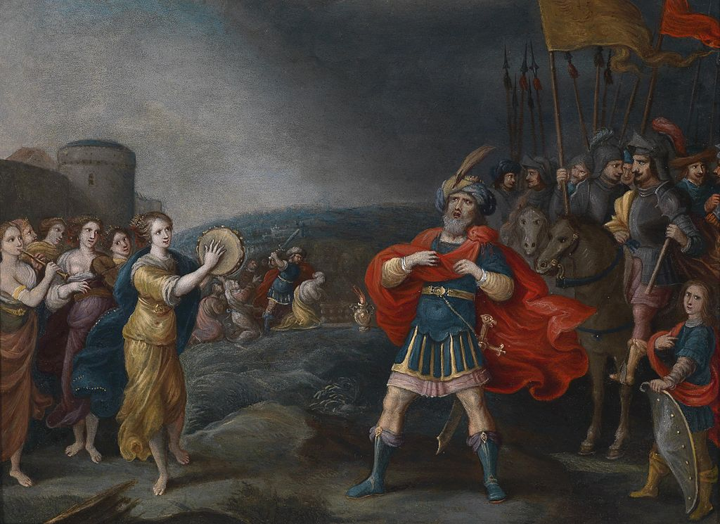
- Ensure that vows and words are kept
When Jephthah returned to his home in Mizpah, who should come out to meet him but his daughter, dancing to the sound of tambourines! She was an only child. Except for her he had neither son nor daughter. When he saw her, he tore his clothes and cried, "Oh! My daughter! You have made me miserable and wretched, because I have made a vow to the LORD that I cannot break." (Judges 11: 34,35)
Be a person of real integrity, consistency and trust. That we may earn a good reputation.

- Ensure true faithfulness irrespective of length and time of service
Jephthah led Israel six years. Then Jephthah the Gileadite died, and was buried in a town in Gilead. (Judges 12:7)
And what more shall I say? I do not have time to tell about Gideon, Barak, Samson, Jephthah, David, Samuel and the prophets, who through faith conquered kingdoms, administered justice, and gained what was promised. (Hebrews 11:32,33a)
It is not about the length of time that we are leaders. Not all of us will be famous nor successful, but it is about how faithful we are to the end. When we are faithful in the little, we will be faithful in much.

Conclusion
Due to the misconduct of its founding pastor, a mega-church in USA, with a congregation of over 25,000 members have been given a bad name. The pastor had to step down.
There may be darkness in our lives that we have not confronted. The darkness is a problem of the flesh. We have to deal with it. Don’t get tripped over. Dig in, don’t deny it. Walk in humility and be brutally honest with yourself so that the darkness can be dealt with.
Areas of darkness may include the following:
Addiction | Deep need of security in life; low self-esteem | Pornography | Sexual immorality
Alcoholism | Been getting negative feedback, cursed. | Tendency to lie, cheat or be cunning and devious. | Extra-marital affair
Gambling & debts | Inferiority complex due to a broken background | An act that can destroy other people’s future. | Lustful thoughts

If the darkness is exposed, it will prevent us from finishing well. Only we know the dark side of our lives. It can be painful or shameful, but God values our heart, our honesty and boldness when we step out to deal with the darkness. God is a god of second chances. He will heal and restore us.
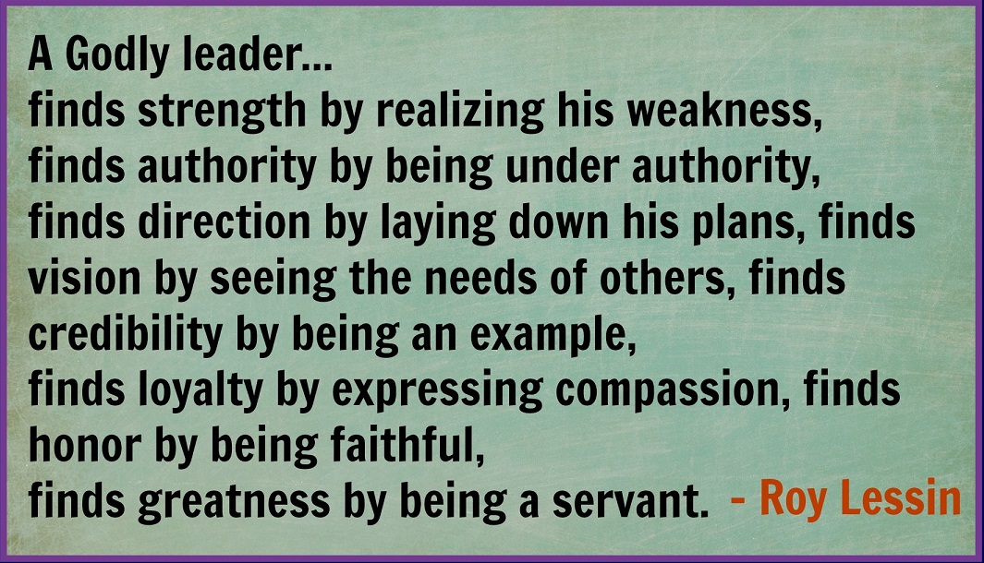

Sermon summary contributed Wendy ML.

