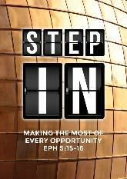
Advent 1: God is Light
Senior Pastor Chris Kam
“The Word became flesh and made his dwelling among us. We have seen his glory, the glory of the one and only Son, who came from the Father, full of grace and truth.” (John 1:14)

When Jesus spoke again to the people, he said, “I am the light of the world. Whoever follows me will never walk in darkness, but will have the light of life.” (John 8:12)

In the past God spoke to our ancestors through the prophets at many times and in various ways, but in these last days he has spoken to us by his Son, whom he appointed heir of all things, and through whom also he made the universe. The Son is the radiance of God’s glory and the exact representation of his being, sustaining all things by his powerful word. After he had provided purification for sins, he sat down at the right hand of the Majesty in heaven. (Hebrews 1:1-3)

Introduction
How many of you like the photo of yourself in your identification card (I.C.), or passport or driving license? Like it or not, it is a representation of you.

Often in life, we do not like what we see in the mirror. We wish to change something about our body. We are never too satisfied with how we look. We all desire to go under the spotlight - the worldly spotlight - to be honoured, accepted, recognized. Under this spotlight, we will never be happy with ourselves. Our pursuit for the wrong spotlight will continue from one thing to another and many of us get trapped in it because we will never be satisfied.

We are like photographic paper. We are sensitive to light. It is a matter of what light we are sensitive to - the world’s spotlight, or the spotlight of Christ / God. Our image depends on that the light.

BIG IDEA: Are You a Good Photograph in the Light of Christ?

How do We Become a Good Photograph?

Yield to the Light - be light sensitive
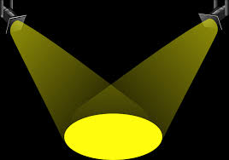
“… Whoever follows me will never walk in darkness, but will have the light of life.” (John 8:12b)
We need to follow Jesus. We need to identify the wrong light and move towards the right spotlight.

According to Randy Pope, we are all applause addicts - when we just want something from other people (“likes” on social media, credits from our bosses). That would just bring about counterfeit glory.

“Like narcotics, the more we get, the more we need.
The more we need, the more dissatisfied we become.
The more dissatisfied we become,
the more extremes we will pursue to continue our search.” (Randy Pope)

We may still have the sinful nature in us. We are recovering applause addicts and we are coming out of that. Only Jesus can help us do that.

Why is there a need for us to want to be in the spotlight? It is not a wrong desire. We are designed to desire glory. We are created in the image of God. We are made for glory. That is the glory that we are after. We have lost it and have been longing for it all the time.

“..for all have sinned and fall short of the glory of God,” (Romans 3:23)

What is this glory? It is of the renowned, honour, pride, acceptance, admiration, magnificence, the desire to be the best, etc. The heart of it is satisfaction. It is when we are not in needing anything more and when can we say that we are truly, truly satisfied in our lives. Not in the things of the world, but that which only God can give full satisfaction. He is our good, good Father and He give good gifts that satisfied.

“God is most glorified when I am most satisfied in Him.” (John Piper)

The focus is on Jesus. He said, “If you have seen me, you have seen the Father.” When we see Jesus, we see the light of God. This glory doesn’t ever fade away. Follow Him faithfully, daily.

Expose to the Light Continually
“… Whoever follows me will never walk in darkness, but will have the light of life.” (John 8:12b)
Bring in the light, and darkness disappears. This is the key of spiritual warfare. Bring in the light so that the demons flee, not merely about casting the demons out. Because of our fleshly nature, we are still in darkness. Darkness will envelope our lives when we are out of the light.

Focus on Christ. Repent, say, “I am sorry.” Live a holy life. Honour Jesus. Do not just focus on getting rid of the bad habit.

Are you stepping into a life of discipleship? Are you reading His Word and worshiping God? Do you have fellowship with other Christians? Do you have an accountability partner? How are you going through the trials of lives?

Bad things tend to happen when there is the absence of God’s presence, but God may allow sufferings because “suffering produces perseverance; perseverance, character; and character, hope. (Romans 5:3-4).

Be sensitive to the light of God, and the light will begin to change us.

Transformed by the Light to Christlikeness
“… Whoever follows me will never walk in darkness, but will have the light of life.” (John 8:12b)
Our character is what would come out from the inside-out. We may be attracted to people or the person inside, regardless of how they look on the outside.

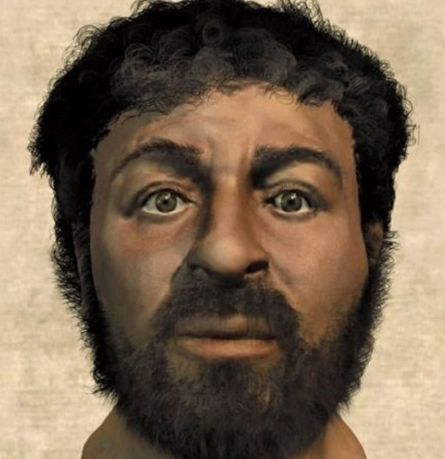
What is the image of Jesus that we have in our mind?
“He had no beauty or majesty to attract us to him, nothing in his appearance that we should desire him. (Isaiah 53:2)
According to the bible, nothing in his appearance would have attracted us to Him. He looked ordinary. Yet, in many paintings, out of what the artists may have read about Jesus, they portray Him the way we see or think of Him today - tall, handsome, gentle, pleasant, kind-hearted.
If there were no cameras and photographs, and if an artist were to draw and paint a portrait of you, without any idea on what you look like, but only based on what has been written about you, what would they draw? How would your picture come out?

When Jesus shine into your life, we will be transformed the inside that will radiate on the outside. You will become more beautiful and godly inside. Only Jesus can give us that glory. That is true glory and that glory honours the Lord.

Conclusion
The Son is the radiance of God’s glory and the exact representation of his being, sustaining all things by his powerful word. After he had provided purification for sins, he sat down at the right hand of the Majesty in heaven. (Hebrews 1:3)

Radiance = shines. What would the glory be like? We only have a glimpse right now because of Jesus was on earth. When Jesus said, “I am the Light.” He was giving us a foretaste of what the future will be.

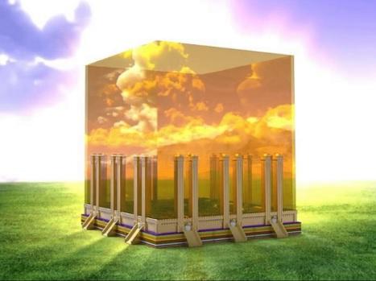
Then I saw “a new heaven and a new earth,” for the first heaven and the first earth had passed away, and there was no longer any sea. I saw the Holy City, the new Jerusalem, coming down out of heaven from God, prepared as a bride beautifully dressed for her husband. And I heard a loud voice from the throne saying, “Look! God’s dwelling place is now among the people, and he will dwell with them. They will be his people, and God himself will be with them and be their God. ‘He will wipe every tear from their eyes. There will be no more death or mourning or crying or pain, for the old order of things has passed away.” (Revelations 21:1-4)

I did not see a temple in the city, because the Lord God Almighty and the Lamb are its temple. The city does not need the sun or the moon to shine on it, for the glory of God gives it light, and the Lamb is its lamp. The nations will walk by its light, and the kings of the earth will bring their splendor into it. (Revelations 21:22-24)

The city that God speaks of refers to the New Jerusalem. According to a calculation, the new city will be 47 times larger than the current largest city in the world (Shanghai), and it can accommodate 39 billion people. It has plenty of room. It will be amazing!

During this advent and Christmas this year, may we remember that Jesus is preparing us for a place of glory that will far outshine every suffering that we have on earth. Apostle Paul was able to go through all the persecution and sufferings because he held on to that glory of God one day. If we do not see that, we can never truly understand when Jesus said, “I am the Light of the world.


Sermon summary contributed Wendy ML.

