
Advent 3: God is Life
Founding Senior Pastor Dato Dr. Daniel Ho

In him was life, and that life was the light of all mankind. (John 1:4)

Then Jesus declared, “I am the bread of life. He who comes to me will never go hungry, and he who believes in me will never be thirsty.” (John 6:35)

The thief comes only to steal and kill and destroy; I have come that they may have life, and have it to the full. (John 10:10)

Introduction
Pastor Daniel mentors a group of young CEO’s below 40. One CEO shared about the fear of not needing God when everything is provided. We need to guard ourselves from the thought that success sees no need for Jesus.

Time flies. We need to learn to grow old gracefully. We are coming to the end of the year.


BIG IDEA: We need to have peace with God and peace of God so that we may have peace with ourselves and share it with the world

The Amazing Truth

Life is found in a person, the Person of Jesus Christ
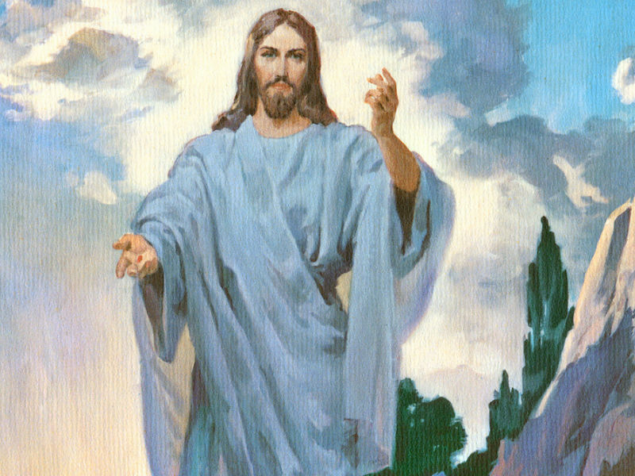
Then Jesus declared, “I am the bread of life. He who comes to me will never go hungry, and he who believes in me will never be thirsty.” (John 6:35)

I am the living bread that came down from heaven. Whoever eats this bread will live forever. This bread is my flesh, which I will give for the life of the world.” (John 6:51)


Charles Zhan introduced the internet to China in 1996. He founded a website called sohu. He started an online service in China. He came back to China with a PhD from MIT. He offered himself to server in the Beijing Olympic Games in 2008. He was climbing high and breaking new grounds. He was rated as the 50th cyber elite by Time Magazine in 1988. Forbes listed him as one of 25 corporate stars in the world in 2011. Yet, he went into depression. He later recovered. He quotes, “I think there’s something wrong with me. I truly have everything, and yet I am so miserable. Happiness is totally unrelated to how much money you have.”

If you have Jesus, you have life
Whoever believes in the Son has eternal life, but whoever rejects the Son will not see life, for God’s wrath remains on them. (Jn. 3:36)

In Jesus, we have significance and security. People struggle to find meaning in life. We need to have the peace of God with us.

It is not just the quantity but the quality

The thief comes only to steal and kill and destroy; I have come that they may have life, and have it to the full. (John 10:10)

It is not the quantity of life but the quality of life that counts. Happiness is not related with how much money we have.

The incredible outcome

Peace I leave with you; my peace I give you. I do not give to you as the world gives. Do not let your hearts be troubled and do not be afraid.( John 14:27)

For to us a child is born, to us a son is given, and the government will be on his shoulders.
And he will be called Wonderful Counselor, Mighty God, Everlasting Father, Prince of Peace. (Isaiah 9:6)

This life offers a peace the world cannot give.


Peace, firstly, with God

Therefore, since we have been justified through faith, we have peace with God through our Lord Jesus Christ. (Rom 5:1)

Then, peace with ourselves within

And the peace of God, which transcends all understanding, will guard your hearts and your minds in Christ Jesus. (Philippians 4:7)

Then, peace with people around us
Finally, brothers, good-bye. Aim for perfection, listen to my appeal, be of one mind, live in peace. And the God of love and peace will be with you. (2 Corinthians 13:11)

God is here in our midst. We do not need to look for it anywhere else.

Finally, peace with God’s creation

The wolf will live with the lamb, the leopard will lie down with the goat, the calf and the lion and the yearling together; and a little child will lead them. (Isaiah 11:6)

We are stewards of God’s creation. We must play a part in preserving the earth. The person who started recycling plastic in Porkara , Nepal was a Christian. Pastor was inspired by the idea and is now looking for Christians who will be involved in recycling projects in Malaysia.

The Remarkable Test

This life can stand the test of time
Therefore we do not lose heart. Though outwardly we are wasting away, yet inwardly
we are being renewed day by day. (2 Corinthians 4:16)

We are getting older everyday whether we like it or not. We must learn to grow old gracefully.

This life can stand the test of trials
For our light and momentary troubles are achieving for us an eternal glory that far
outweighs them all. (2 Corinthians 4:17)

Consider it pure joy, my brothers, whenever you ace trials of many kinds, because you know that the testing of your faith develops perseverance. Perseverance must finish its work so that you may be mature and complete, not lacking anything. (James 1:2-4)

When Pr. Ravi Zecharias was in Vietnam, he had a Vietnamese translator. The government caught him and tortured him for years because they thought he was a spy working with the CIA. He was brainwashed to a point he stopped praying. He was assigned to wash the toilets. He worked and worked. As he was cleaning, he found a slip of paper that was from the bible. He washed it and read it. It was a passage from Romans chapter 8.

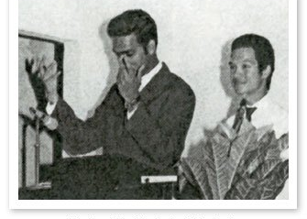
What, then, shall we say in response to these things? If God is for us, who can be against us? He who did not spare his own Son, but gave him up for us all—how will he not also, along with him, graciously give us all things? Who will bring any charge against those whom God has chosen? It is God who justifies. Who then is the one who condemns? No one. Christ Jesus who died—more than that, who was raised to life—is at the right hand of God and is also interceding for us. Who shall separate us from the love of Christ? Shall trouble or hardship or persecution or famine or nakedness or danger or sword? As it is written: “For your sake we face death all day long; we are considered as sheep to be slaughtered.” Romans 8:31 -36)

The commander was tearing the Bible and using it as toilet paper. God can encounter us in the least expected places. God revealed himself to this person just as he gave up his faith.

This life can stand the test of eternity
So we fix our eyes not on what is seen, but on what is unseen. For what is seen is temporary, but what is unseen is eternal. (2 Corinthians 4:19)

Jesus said to her, "I am the resurrection and the life. He who believes in me will live, even though he dies; and whoever lives and believes in me will never die. Do you believe this?” (John 11:25,26)

Only God can bring us eternal life. Life produces life.

The Awesome Reality
Some of them, however, men from Cyprus and Cyrene, went to Antioch and began to speak to Greeks also, telling them the good news about the Lord Jesus. The Lord's hand was with them, and a great number of people believed and turned to the Lord. (Acts 11:20,21)
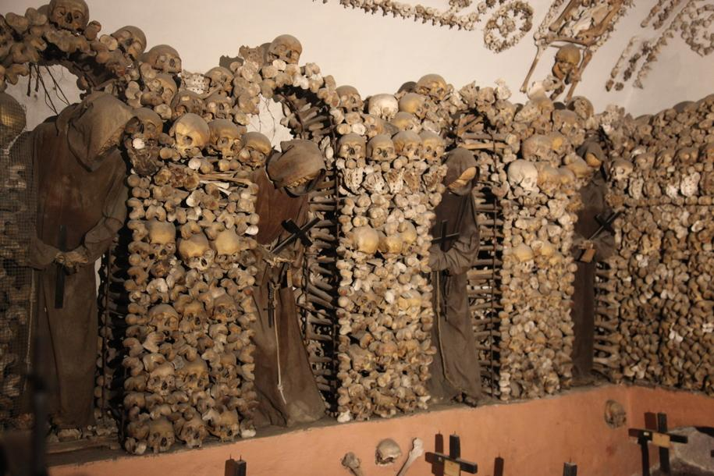
God’s people were in hiding during Roman times. When Pastor Daniel was in Rome, he asked to visit the catacombs. Romans were worshipping here during the reign of the emperors. It took centuries before the emperor became a Christian. The catacombs stretched for miles and miles and was a good place to hide as they were used to bury the dead. Living life is not about length but the depth.

Conclusion: The Urgent Need
Jesus said to her, "I am the resurrection and the life. He who believes in me will live, even though he dies; and whoever lives and believes in me will never die. Do you believe this?” (John 1

Dr Daniel and Doris were in Portugal. A cleaner, who claimed to be a sort of Christian cleaned the room for them. To respect her time at work, Pastor Daniel asked one minute to pray for her after her cleaning work. Upon finishing. she shared she was from Romania and came to work in Portugal due to the bad condition there. Her husband left her when she was seven months pregnant. Now, her son is due for a surgery. Pastor Daniel prayed for her. She cried and could not control herself. There are people looking good outside but hurting inside. Get people to encounter Jesus. Two days later, she was smiling when they saw her.

Sermon summary contributed Abbey Thangiah.

