
Stepping Forward in Societal Transformation
(Daniel 6:1-12, 19-28)
Dato’ Dr Daniel Ho, Founding Senior Pastor

It pleased Darius to appoint 120 satraps to rule throughout the kingdom, with three administrators over them, one of whom was Daniel. The satraps were made accountable to them so that the king might not suffer loss. Now Daniel so distinguished himself among the administrators and the satraps by his exceptional qualities that the king planned to set him over the whole kingdom. At this, the administrators and the satraps tried to find grounds for charges against Daniel in his conduct of government affairs, but they were unable to do so. They could find no corruption in him, because he was trustworthy and neither corrupt nor negligent. Finally these men said, “We will never find any basis for charges against this man Daniel unless it has something to do with the law of his God.” So these administrators and satraps went as a group to the king and said: “May King Darius live forever! The royal administrators, prefects, satraps, advisers and governors have all agreed that the king should issue an edict and enforce the decree that anyone who prays to any god or human being during the next thirty days, except to you, Your Majesty, shall be thrown into the lions’ den. Now, Your Majesty, issue the decree and put it in writing so that it cannot be altered—in accordance with the law of the Medes and Persians, which cannot be repealed.” So King Darius put the decree in writing. Now when Daniel learned that the decree had been published, he went home to his upstairs room where the windows opened toward Jerusalem. Three times a day he got down on his knees and prayed, giving thanks to his God, just as he had done before. Then these men went as a group and found Daniel praying and asking God for help. So they went to the king and spoke to him about his royal decree: “Did you not publish a decree that during the next thirty days anyone who prays to any god or human being except to you, Your Majesty, would be thrown into the lions’ den?” The king answered, “The decree stands—in accordance with the law of the Medes and Persians, which cannot be repealed.” (Daniel 6:1-12)

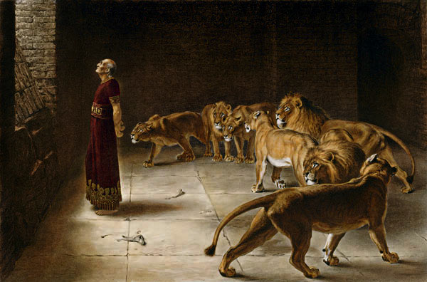
At the first light of dawn, the king got up and hurried to the lions’ den. When he came near the den, he called to Daniel in an anguished voice, “Daniel, servant of the living God, has your God, whom you serve continually, been able to rescue you from the lions?” Daniel answered, “May the king live forever! My God sent his angel, and he shut the mouths of the lions. They have not hurt me, because I was found innocent in his sight. Nor have I ever done any wrong before you, Your Majesty.”

The king was overjoyed and gave orders to lift Daniel out of the den. And when Daniel was lifted from the den, no wound was found on him, because he had trusted in his God. At the king’s command, the men who had falsely accused Daniel were brought in and thrown into the lions’ den, along with their wives and children. And before they reached the floor of the den, the lions overpowered them and crushed all their bones. Then King Darius wrote to all the nations and peoples of every language in all the earth: “May you prosper greatly! I issue a decree that in every part of my kingdom people must fear and reverence the God of Daniel. For he is the living God and he endures forever; his kingdom will not be destroyed, his dominion will never end. He rescues and he saves; he performs signs and wonders in the heavens and on the earth. He has rescued Daniel from the power of the lions.” So Daniel prospered during the reign of Darius and the reign of Cyrus the Persian. (Daniel 6: 19-28)

Introduction

Babylon is one of the most famous cities of antiquity. It is highly advanced in its engineering and architecture, and is one of the most powerful and influential cities in Mesopotamia. Daniel and his three friends came as foreigners to the city and they were educated in the language and literature of the Babylonians. Daniel was influential in the Babylonian as well as the Persian and Medes empire. Even though he was a foreigner, God used him in a powerful way to make a difference in the city.

Four commitments in societal transformation:

Character

Now Daniel so distinguished himself among the administrators and the satraps by his exceptional qualities that the king planned to set him over the whole kingdom. At this, the administrators and the satraps tried to find grounds for charges against Daniel in his conduct of government affairs, but they were unable to do so. They could find no corruption in him, because he was trustworthy and neither corrupt nor negligent. Finally these men said, “We will never find any basis for charges against this man Daniel unless it has something to do with the law of his God.” (Daniel 6:3-5)

As a person
Daniel was marked by integrity and spirituality. He was an upright person with no corruption. He was a man who feared God. As believers, we need to fear God more than we fear man. The Bible says that the fear of man is a snare. We honour man, but we fear God. If we fear God, God will guide us in what we do. We need to stand firm and steadfast, playing only by biblical rules and not compromising in any way.

In performance
Daniel’s work was marked by excellence and diligence. We may not be very intelligent or academically brilliant, but we can be good with our hands. We need to be diligent and proud of what we do or produce, to put our heart and mind in our workmanship.

Courage
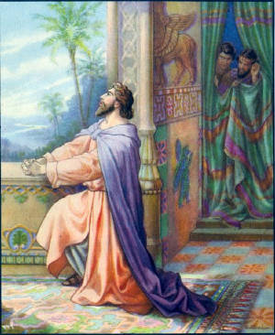
Now when Daniel learned that the decree had been published, he went home to his upstairs room where the windows opened toward Jerusalem. Three times a day he got down on his knees and prayed, giving thanks to his God, just as he had done before. (Daniel 6:10)

Unafraid to take a stand
Daniel continued to do what is right even after learning about the decree. We need to be unafraid to take a stand, even if it is difficult or painful. If we do not take a stand, we are not living life on the cutting edge. No difference will be made. The earlier we make a stand, the easier it is for us to make future stands. Establish your position from the very beginning and make your stands clear. Be consistent about your stands and honour God in every way.

Fearless in not compromising
Shadrach, Meshach and Abednego replied to him, “King Nebuchadnezzar, we do not need to defend ourselves before you in this matter. If we are thrown into the blazing furnace, the God we serve is able to deliver us from it, and he will deliver us from Your Majesty’s hand. But even if he does not, we want you to know, Your Majesty, that we will not serve your gods or worship the image of gold you have set up.” (Daniel 3:16-18)

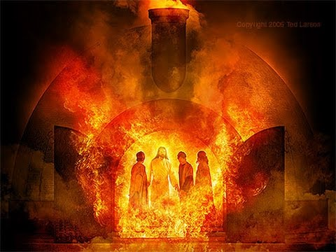
Daniel’s friends chose to serve and honour God above King Nebuchadnezzar, and trust that God will save them. They went as far as to say that even if God does not save them, they will not serve the gods or worship the image of gold the king has set up. They took a stand and they were fearless about it. They feared and trusted God. Just as Daniel did.

Cost

Then the men went as a group to King Darius and said to him, “Remember, Your Majesty, that according to the law of the Medes and Persians no decree or edict that the king issues can be changed.” So the king gave the order, and they brought Daniel and threw him into the lions’ den. The king said to Daniel, “May your God, whom you serve continually, rescue you!” (Daniel 6:15-16)

Recognising there is a price to pay
Then Nebuchadnezzar was furious with Shadrach, Meshach and Abednego, and his attitude toward them changed. He ordered the furnace heated seven times hotter than usual and commanded some of the strongest soldiers in his army to tie up Shadrach, Meshach and Abednego and throw them into the blazing furnace. So these men, wearing their robes, trousers, turbans and other clothes, were bound and thrown into the blazing furnace. (Daniel 3:19-21)

Following Christ and taking a stand on what is right may cost you something. In some cases, you may lose your job, and you may experience rejection from your family and friends.

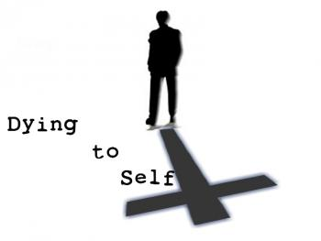
Making a difference never comes cheap or easy
Then he said to them all: “Whoever wants to be my disciple must deny themselves and take up their cross daily and follow me.” (Luke 9:23)

“When Christ calls a man He bids him come and die.” – Dietrich Bonhoeffer

Following Christ requires us to die to ourselves so that we may live for Him. We are no longer living for ourselves, but for Christ, who gave Himself up for us.

Call
Then they said to the king, “Daniel, who is one of the exiles from Judah, pays no attention to you, Your Majesty, or to the decree you put in writing. He still prays three times a day.” When the king heard this, he was greatly distressed; he was determined to rescue Daniel and made every effort until sundown to save him. (Daniel 6:13-14)

To be in the world but not of the world
They are not of the world, even as I am not of it. Sanctify them by the truth; your word is truth. As you sent me into the world, I have sent them into the world. (John 17:16-18)
The king and Daniel had a wonderful relationship. He was worried for Daniel and thought of ways to save him.

To be salt and light

“You are the salt of the earth. But if the salt loses its saltiness, how can it be made salty again? It is no longer good for anything, except to be thrown out and trampled underfoot. “You are the light of the world. A town built on a hill cannot be hidden. (Matthew 5:13-14)

Salt is used to give flavour to food and light is used to brighten the darkness. We are called to be salt and light of the world around us, to make a difference wherever we are.

How to make a difference in our workplace, home, community or place of study:

- Pray for your colleagues or your classmates, for God to prepare and open their hearts and minds to receive the Gospel and salvation. Pray for opportunities to share the Gospel with them.
- Be excellent in what you do. Do it well to the glory of God.
- Be personal. Go out for lunches with your colleagues/classmates, and find out those who are open to deeper conversations.
- Talk about all kinds of topics and share about what God has done for you and how God has changed and transformed your life.
Conclusion
Societal transformation requires a kind of character, courage, cost, and answering of the call of God in our workplace, home, community and place of study. We are called to bear witness and to live out our faith wherever we are, in order to make a difference. Commit to seeing your workplace, home, community and place of study being transformed as you continue to pray and share the love of Christ with those in your realm of influence.

“We are the Bibles the world is reading; we are the creeds the world is needing; we are the sermons the world is heeding.”

Billy Graham

Sermon summary by Anthea

