
W2W Weekend: I have a dream
(Proverbs 29:18, Proverbs 31:10-31)
Stella Hoh

Where there is no revelation, people cast off restraint; but blessed is the one who heeds wisdom’s instruction. (Proverbs 29:18)

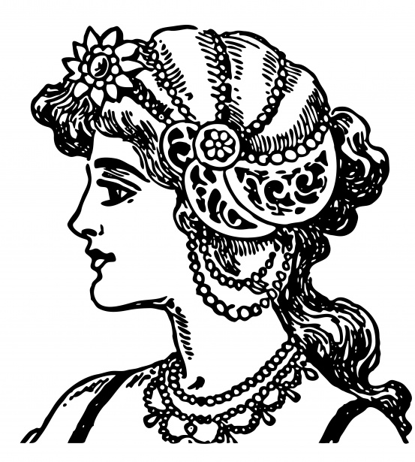
A wife of noble character who can find? She is worth far more than rubies. Her husband has full confidence in her and lacks nothing of value. She brings him good, not harm, all the days of her life. She selects wool and flax and works with eager hands. She is like the merchant ships, bringing her food from afar. She gets up while it is still night; she provides food for her family and portions for her female servants. She considers a field and buys it; out of her earnings she plants a vineyard. She sets about her work vigorously; her arms are strong for her tasks. She sees that her trading is profitable, and her lamp does not go out at night. In her hand she holds the distaff and grasps the spindle with her fingers. She opens her arms to the poor and extends her hands to the needy. When it snows, she has no fear for her household; for all of them are clothed in scarlet. She makes coverings for her bed; she is clothed in fine linen and purple. Her husband is respected at the city gate, where he takes his seat among the elders of the land. She makes linen garments and sells them, and supplies the merchants with sashes. She is clothed with strength and dignity; she can laugh at the days to come. She speaks with wisdom, and faithful instruction is on her tongue. She watches over the affairs of her household and does not eat the bread of idleness. Her children arise and call her blessed; her husband also, and he praises her: “Many women do noble things, but you surpass them all.” Charm is deceptive, and beauty is fleeting; but a woman who fears the Lord is to be praised. Honor her for all that her hands have done, and let her works bring her praise at the city gate. (Proverbs 31:10-31)

Introduction
Many men wish that their wives can be like the Proverbs 31 woman but she can intimidate men with her achievements and success. Women, on the other hand, may either be inspired by this woman or feel that they are failures as they do not measure up. Some may also feel that this passage does not apply to their lives or that it is too old-fashioned. However, there are a number of truths in this passage.

The phrase “I have a dream” was popularised by Martin Luther King to inspire the black people to freedom. This phrase does not just change nations but applies to every single one of us. Women often play multiple roles which impact the lives of others. All of us have dreams and ambitions which surround the roles that we play.

God has created us to stretch and grow. Storms are necessary as a process to grow. Many of us know the roles we play and our context as Christians as we carry out our duties faithfully. However, God still wants us to grow and stretch.

BIG IDEA: Don’t settle for just your dreams. Go for God’s!

My dream. God’s dream.
Most of us believe that we are carrying out the roles that we are doing but we need to dream bigger.

Roles we play
*As daughters – to honour our parents.
*As employees/employers – to climb the ladder, to make profits and grow the business.
*As homemakers – to ensure the home is safe, beautiful and clean.
*As wives – to look good and support our husbands.
*As mothers – to ensure our children are given the best.
We subconsciously try to be the Proverbs 31 lady. However, we need to think bigger.
Story: Toilet cleaner in Changi airport
A cleaner offered to help a passenger who was looking for a particular shop and gave him the directions to his destination. He was impressed that she would know where the shop is and was curious so decided to ask her. She said, “I may clean the toilet but I work in Changi airport. There are many foreigners who transit in Changi airport. It is my duty as I work in Changi airport so that I can help them and be a good ambassador of Singapore.”
The cleaner may be paid to do her job of cleaning toilets but she did not stop there. She had a bigger dream and a bigger role where she saw the need to know much more than the role that she played. We have a role to play and we do a great job but God wants us to not to just do that role but to do a bigger thing and have a bigger dream.
Where there is no vision, the people perish: but he that keepeth the law, happy is he.- King James Version

Where there is no revelation, people cast off restraint; but blessed is the one who heeds wisdom’s instruction. – New International Version

If people can’t see what God is doing, they stumble all over themselves; But when they attend to what he reveals, they are most blessed. – The Message
(Proverbs 29:18)

The Hebrew word for vision / revelation here is “Chazon” which is more appropriately meant to be God’s law / word. Perish is not about dying but is meant to “cast off restraint”.

If we can see our role in the context of what God wants us to do, it becomes more meaningful and purposeful. We will know what we are doing and be more fulfilled.


God’s Word reminding us that we are:

Aliens
Dear friends, I urge you, as aliens and strangers in the world, to abstain from sinful desires, which war against your soul. (1 Peter 2:11 - NIV 1984)

Transformers
Do not conform to the pattern of this world, but be transformed by the renewing of your mind. Then you will be able to test and approve what God’s will is—his good, pleasing and perfect will. (Romans 12:2)

Soldiers in spiritual warfare
For our struggle is not against flesh and blood, but against the rulers, against the authorities, against the powers of this dark world and against the spiritual forces of evil in the heavenly realms. (Ephesians 6:12)

Missional - here to fulfill the Great Commission.
Therefore go and make disciples of all nations, baptizing them in the name of the Father and of the Son and of the Holy Spirit, and teaching them to obey everything I have commanded you. And surely I am with you always, to the very end of the age.” (Matthew 28:19-20)

We need to see the people around us who need God and God’s heart is for the people he has put us with.

These roles are what God wants us to be. God therefore does not want us to be too comfortable in this world. In whatever we do, we must remember that God wants us to see a bigger role for ourselves. God has a purpose for where you are which is much bigger than what you think it is. For example, Queen Esther was a queen and a wife but she was asked to save her nation within the role that she had. We are not asked to shift our roles but to shift our eyes. We will start changing the way we live out our dreams.

Go for God’s dreams!

How our roles can become a bigger dream based on God’s Word/Revelation:


Marriage:
Our dream – Man & Woman.
God’s dream - Jesus & Church.

“For this reason a man will leave his father and mother and be united to his wife, and the two will become one flesh.” This is a profound mystery—but I am talking about Christ and the church. However, each one of you also must love his wife as he loves himself, and the wife must respect her husband. (Ephesians 5:31-33).

Marriage is not just about love and companionship. We are not to find fulfilment in our spouses but in Christ. Marriage reflects Jesus and the church where the husband is like Christ loving his wife (analogous to the church) no matter how terrible we are.

Parenting:
Our dream - Good children.
God’s dream - Godly children

I am reminded of your sincere faith, which first lived in your grandmother Lois and in your mother Eunice and, I am persuaded, now lives in you also. (2 Timothy 1:5)


According to Mr Moses Tay, parents should bring up children to be ready to die for Jesus. We should not expect the world to love our children if they are Christians. We need to prepare the children to die for Jesus.

Family:
Our dream - Parents and children with a roof over our heads.
God’s dream - the community unit to influence the neighbourhood, society and nation.

As Jesus and his disciples were on their way, he came to a village where a woman named Martha opened her home to him. (Luke 10:38)

God always works in community as a Trinity God. In a family, there is father, mother and the children. He wants the community unit to influence the neighbourhood, society and nation as we need to be missional. We need to show hospitality like Martha and Mary.

Work:
Our dream – Career aspiration.
God’s dream – Providence, productivity, responsibility, missional and new Jerusalem.

God created the Earth, man and woman to work.

Be faithful in your role but have a bigger picture so that we do not just chase our dreams but God’s dreams.

My limitation. God’s empowerment!

We need to stretch and go beyond our limitations. The things mentioned in Proverbs 31 is not possible because of us but because of God.

Proverbs 31:10-31 – 5 reasons why it should not be scary:

Written to a man
The passage was about a mother writing advice to son who is a king.

Not a prescription for how women should measure up

Is a song of praise for men to sing

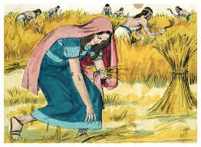
Applies not only to wives but to singles
The phrase “a noble woman who can find?” (Proverbs 31:10) comes from the Hebrew word “eshet chayil,” which can be translated as “woman of valour.”. This was the same description used on Ruth by Boaz in Ruth 3:11 before she was married to Boaz.

And now, my daughter, don’t be afraid. I will do for you all you ask. All the people of my town know that you are a woman of noble character. (Ruth 3:11)

It’s likely an allegorical character, not a real woman
Women in the Bible were not perfect either. However, Proverbs 31 does outline the image that God wants us to have.

As a checklist, do you demonstrate these attributes? This is a Proverbs 31 lady.
- Trustworthy
Her husband has full confidence in her and lacks nothing of value. (Proverbs 31:11)
- Hardworking
She selects wool and flax and works with eager hands. (Proverbs 31:13)
She sets about her work vigorously; her arms are strong for her tasks. (Proverbs 31:17)
She watches over the affairs of her household and does not eat the bread of idleness. (Proverbs 31:27)
- Resourceful
She is like the merchant ships, bringing her food from afar. (Proverbs 31:14)
In her hand she holds the distaff and grasps the spindle with her fingers. (Proverbs 31:19)
She makes coverings for her bed; she is clothed in fine linen and purple. (Proverbs 31:22)
She makes linen garments and sells them, and supplies the merchants with sashes. (Proverbs 31:24)
- Makes good use of time
She gets up while it is still night; she provides food for her family and portions for her female servants. (Proverbs 31:15)
She sees that her trading is profitable, and her lamp does not go out at night. (Proverbs 31:18)
- Good with money
She considers a field and buys it; out of her earnings she plants a vineyard. (Proverbs 31:16)
- Generous
She opens her arms to the poor and extends her hands to the needy. (Proverbs 31:20)
- Thinks ahead
When it snows, she has no fear for her household; for all of them are clothed in scarlet. (Proverbs 31:21)
- Wise
She is clothed with strength and dignity; she can laugh at the days to come. (Proverbs 31:25)

We may not be 100% but we are Proverbs 31 ladies as we have these attributes. We have our limitations but God has His empowerment as that is what God envisions us to be. He will enable us to do the things that He wants us to.

God’s dream. Our dream.

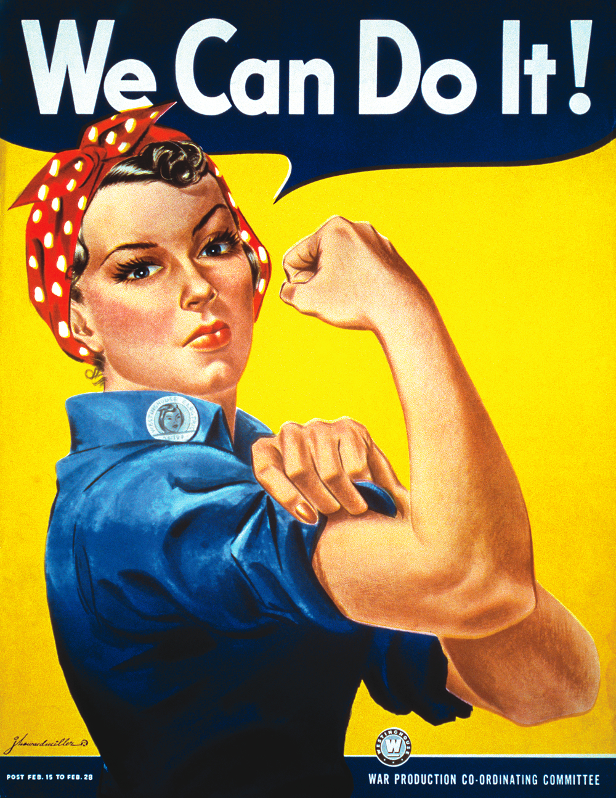
Men and women work together in synergy as a team.

A caution to ladies:

Women are meant to be helpmates as men and women work together to fulfil God’s dream. God gave us capabilities to be helpmates. We should neither put men down nor compare ourselves to them. Capabilities in God’s view do NOT equate to being better leaders or being superior to men.
Leadership is an appointment by God. Leaders are anointed by God.

A caution to gentlemen and other ladies:


Besides betrayal, dreams can be suppressed or broken in other ways.

Disinterest
When was the last time you had a quality conversation with the ladies in your life about their passion or interest? And you truly listened?

Dominance
Have you implied to a lady that she is not as important or she is not as good? Or cut her off when she said something?

Discouragement (wet blanket)
Ever you said to a lady that her suggestions were not good enough? Or even called her stupid? Or teased her for her looks or actions? Or would not drive her to a church activity when she wanted badly to attend/serve?

If you have had your dreams broken or watered down, don’t stay down. We can break dreams, but we can also build dreams. Encourage others rather than the other way around.

Conclusion
God has empowered us so that together, as men and women, we can embrace God’s dream and encourage one another.

The fact that I am a woman does not make me a different kind of Christian, but the fact that I am a Christian makes me a different kind of woman.

Elisabeth Elliot

Sermon summary by Zhenli

