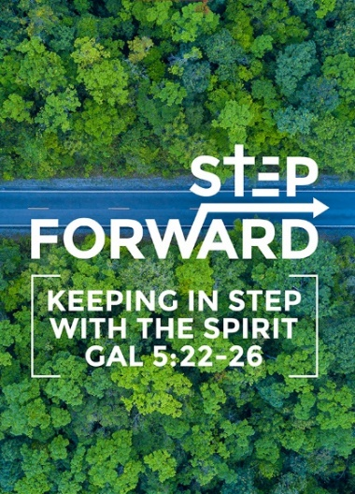
She Ain't Perfect, She's My Mother (Ruth 1:16-22)
Pastor Sara Leong

But Ruth replied, “Don’t urge me to leave you or to turn back from you. Where you go I will go, and where you stay I will stay. Your people will be my people and your God my God. Where you die I will die, and there I will be buried. May the Lord deal with me, be it ever so severely, if even death separates you and me.” When Naomi realized that Ruth was determined to go with her, she stopped urging her. So the two women went on until they came to Bethlehem. When they arrived in Bethlehem, the whole town was stirred because of them, and the women exclaimed, “Can this be Naomi?” “Don’t call me Naomi,” she told them. “Call me Mara, because the Almighty has made my life very bitter. I went away full, but the Lord has brought me back empty. Why call me Naomi? The Lord has afflicted me; the Almighty has brought misfortune upon me.” So Naomi returned from Moab accompanied by Ruth the Moabite, her daughter-in-law, arriving in Bethlehem as the barley harvest was beginning. (Ruth 1:16-22)

Introduction

As we celebrate Mother’s Day this weekend we reflect on Susanna Wesley, the mother of John Wesley. She raised 10 children and taught them to recite the Lord’s Prayer once they could speak. They would begin the day with reading or singing the Psalms. Education and faith in God was important to her and her methods of raising her children produced one of the greatest men of faith.

In the way she loved (Ruth 1:8-9)
Then Naomi said to her two daughters-in-law, “Go back, each of you, to your mother’s home. May the Lord show you kindness, as you have shown kindness to your dead husbands and to me. May the Lord grant that each of you will find rest in the home of another husband.” (Ruth 1:8-9)
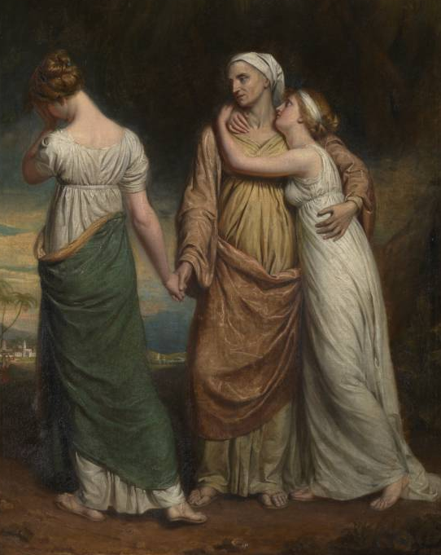
Naomi followed her husband to Moab when he uprooted the family as there was a famine in Bethlehem. It was supposed to be a place of hope, but it became a place of despair. First her husband died and then both her sons also died.

- Naomi released her daughters-in-law in hope of a better future for them.
- By letting them go, she was left defenceless.
A mother's love is often times selfless. No matter how tired or unwell they are, they will take care of her family’s needs. They put others before them. Naomi told her daughters-in-laws to go back to their father’s house knowing that would mean that she would be all alone.

The way she handled grief (Ruth 1:19-21)
So the two women went on until they came to Bethlehem. When they arrived in Bethlehem, the whole town was stirred because of them, and the women exclaimed, “Can this be Naomi?” “Don’t call me Naomi,” she told them. “Call me Mara, because the Almighty has made my life very bitter. I went away full, but the Lord has brought me back empty. Why call me Naomi? The Lord has afflicted me; the Almighty has brought misfortune upon me.” (Ruth 1:19-21)
- Loss Is painful.
- Change is hard. To uproot herself to Moab and now to uproot to go back without her family.
- Name change: From Naomi which means pleasant To Mara which means bitter.
She felt loveless because she lost her husband, man-less because she lost her 2 sons and husband and wealth-less because at her age she would not be able to fend for herself.

Her story was far greater than what was happening. What looked hopeless and like a mess, God was at work, weaving a hope and a future. From Naomi and Ruth came the royal linage of King David and Jesus.

God may seem far away in your situation but take heart and know that when all hope seems loss, we can find hope and God is at work.

How things appear to be and how they are, are rarely the same.

The way she inspired faith in Ruth (Ruth1:16)
But Ruth replied, “Don’t urge me to leave you or to turn back from you. Where you go I will go, and where you stay I will stay. Your people will be my people and your God my God. (Ruth1:16)

Ruth was willing to leave everything and everyone she knew to follow Naomi to place where everything would be new and unfamiliar. There was no guarantee of how they would make ends meet.
Ruth must have seen something in Naomi and the God Naomi believed in.
- What did Naomi do to have inspired faith and loyalty from Ruth's end?
- Naomi communicated a God that Ruth wanted for herself.

The way we live our life as a Christian, will it inspire our children to want the faith that we have?
To want to believe and serve the God that we serve?

Conclusion
The beginning of the book of Ruth started off with Naomi's loss. The ending resulted Naomi's gain.
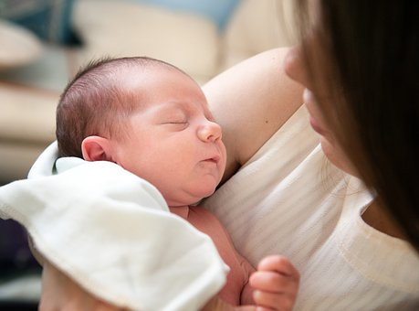
It began with death, the death of her husband and her 2 sons but ended with a birth. The birth of Ruth’s son but the women in the town said that “Naomi has a son” (Ruth 4:17).

There is always hope.

At the end of the day, our children belong to God. Just take care of them the best that you can and trust and rely on God to also take care of them.
Even when it gets tough, keep at it.

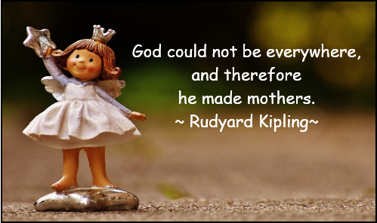

Sermon summary by Prudence.

