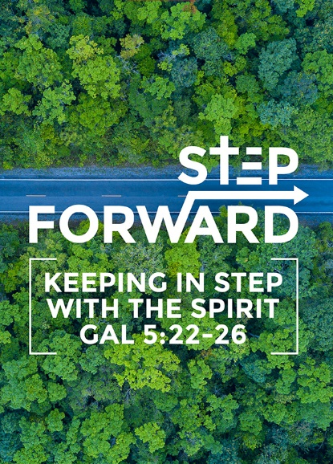
The Gospel, for Salvation
Pastor Mike Ngui

“The wrath of God is being revealed from heaven against all the godlessness and wickedness of people, who suppress the truth by their wickedness, since what may be known about God is plain to them, because God has made it plain to them. For since the creation of the world God’s invisible qualities—his eternal power and divine nature—have been clearly seen, being understood from what has been made, so that people are without excuse. For although they knew God, they neither glorified him as God nor gave thanks to him, but their thinking became futile and their foolish hearts were darkened. Although they claimed to be wise, they became fools and exchanged the glory of the immortal God for images made to look like a mortal human being and birds and animals and reptiles. Therefore God gave them over in the sinful desires of their hearts to sexual impurity for the degrading of their bodies with one another. They exchanged the truth about God for a lie, and worshiped and served created things rather than the Creator—who is forever praised. Amen.”

“Therefore no one will be declared righteous in God’s sight by the works of the law; rather, through the law we become conscious of our sin. But now apart from the law the righteousness of God has been made known, to which the Law and the Prophets testify. This righteousness is given through faith in Jesus Christ to all who believe. There is no difference between Jew and Gentile, for all have sinned and fall short of the glory of God, and all are justified freely by his grace through the redemption that came by Christ Jesus. God presented Christ as a sacrifice of atonement, through the shedding of his blood—to be received by faith. He did this to demonstrate his righteousness, because in his forbearance he had left the sins committed beforehand unpunished— he did it to demonstrate his righteousness at the present time, so as to be just and the one who justifies those who have faith in Jesus. (Romans 1:18-25, 3:20-26)

Introduction
Recap from last week: The Gospel is the “A to Z” of the Christian life. The gospel is good news, it is good for all, and it is good for all of life. At the heart of it all, our understanding of the Bible drives every part of our Christian walk. The more we know and understand the work of Christ, the more we will realize how much has been accomplished and given to us.

BIG IDEA: God saves sinners through Christ.

Good news is only good relative to what is bad. Good news is appreciated, realized and embraced when we begin to understand the bad news that preceded it.

The First Segment, The Sad, and the Bad News.


The First Segment
Not only was it not bad, it was very good. In Genesis 1, ‘good’ was mentioned 6 times. In fact, on the 6th times, it was ‘very good’.
“God saw all that he had made, and it was very good.” (Genesis 1:31a)
It denotes that God’s creation was great and fantastic, like paradise.
God is the greatest judge of what is good. So, when He says it is good, it is definitely very good.
Then, in Genesis 2, God created man, planted a garden and placed man in the garden.
Now the Lord God had planted a garden in the east, in Eden; and there he put the man he had formed. The Lord God made all kinds of trees grow out of the ground—trees that were pleasing to the eye and good for food. (Genesis 2:8-9a)

From the first two chapters of the bible, the story began good. His creation was good. God’s intent for man was good. Adam and Eve was put in a good place of beauty, harmony, provision and peace.

The Sad News
Adam and Eve did not act in faith towards God. They were allowed to eat fruit from all the trees except one that is prohibited. When they ate of it, the Fall happened, and man was banished from the Garden of Eden. Paradise was lost because of sin. We lost it too because of their sin. The spoiler of life is sin.

The sense of lost is there because we may have an inkling or desire for something beautiful, which somehow we just do not get to have. We long for things peace or a place that is secure and harmonious.

“Like Adam, we have all lost Paradise; and yet we carry Paradise around inside of us in the form of a longing for, almost a memory of, a blessedness that is no more, or the dream of a blessedness that may someday be again.” ~Frederick Buechner

The Nature of Sin:

- Sin is refusing to acknowledge the truth of God
The wrath of God is being revealed from heaven against all the godlessness and wickedness of people, who suppress the truth by their wickedness, since what may be known about God is plain to them, because God has made it plain to them. (Romans 1:18-19)

Some refuse to acknowledge the existence of God, and even the possibility of His existence.

- Sin is refusing to acknowledge God’s character
For although they knew God, they neither glorified him as God nor gave thanks to him, but their thinking became futile and their foolish hearts were darkened. Although they claimed to be wise, they became fools and exchanged the glory of the immortal God for images made to look like a mortal human being and birds and animals and reptiles. (Romans 1:21-23)

Adam and Eve did not trust in the character of God. They did not glorify Him as God and neither did they give thanks to God. They did not acknowledge God as one who is good and gracious.

“Sin is cosmic ingratitude” ~Timothy Keller

Sin is a refusal to give thanks to God for what we have. It is the refusal to acknowledge God as the provider. It is the refusal to recognize that God is the one who gave us the breath of life. Sin is the refusal to acknowledge that God is good, merciful and gracious.

One of the greatest sins is the rejection of what God has revealed of himself.

We sometimes see God as wicked, malicious and impotent. His motivation is suspect. That He is not good to us nor can He do anything for us so we are better off taking care of ourselves. That He does not really care so we need to worry about our future. That He is too strict and all out to punish us. That He is just an actor out to gain allegiance and have people on His team. That is just a player in this world and that we are merely His pawn and is often out maneuvered by His adversary. That He is weak and not as clever.

These are lies, lies, and lies!

- When we do not give God the honour and the trust that is due Him, we sin.
- When we drop Him of His glory as the Almighty God, all powerful and sovereign, we sin.
- When we do not ascribe to Him the worth that is due to Him, we sin.
- When we say that He is not trustworthy, we sin.

- Sin is rebellion against God
It is when we tell God, “Stay out of my life. I run my own life.”
“You will not certainly die,” the serpent said to the woman. “For God knows that when you eat from it your eyes will be opened, and you will be like God, knowing good and evil.” (Genesis 3:4-5)

Lies such as these are like fake news. If you believe in the fake news about God, you will not believe that God is good nor trust in Him.

When we rebel against God, we minimize and diminish God and refuse the righteous authority over us. Sin is a distrust and disregard of God; an indifference towards God and an usurping of authority in our lives.

The Bad News

“for all have sinned and fall short of the glory of God,” (Romans 3:23)
All of us are guilty. We tend to think of sin as actions (the things we do) but sin is more than that. Sin begins on the inside (our hearts, mind and attitude). All these things will say something about our relationship with God.

For the wages of sin is death, but the gift of God is eternal life in Christ Jesus our Lord. (Romans 6:23)
If God is the author of life. He is the one who gives life. In Him, there is life. When we turn away from Him, we are denying Him. In sin, we become unplugged from Him.

Death can be both in the physical or the eternal.

The really, really bad news is that, this death that begin in our lives continues to die in our lives and ends in physical death. This situation of being unplugged from God becomes permanent and irreversible in eternity. The disconnect with God becomes a permanent and irreversible state if not remedied before we die the physical death.

The bad news is that we cannot do anything about it ourselves.
“Therefore no one will be declared righteous in God’s sight by the works of the law; rather, through the law we become conscious of our sin.” Romans 3:20
You can work your life all out to live good and righteous lives, but no one will be declared righteous.

The Great News of the Gospel.

God reached out.

But God demonstrates his own love for us in this: While we were still sinners, Christ died for us. (Romans 5:8)

He intervened. Despite our rebellion, God, out of His love, acted unilaterally to rescue us. He made a way for humanity to be reconciled / returned to God and made right with Him.

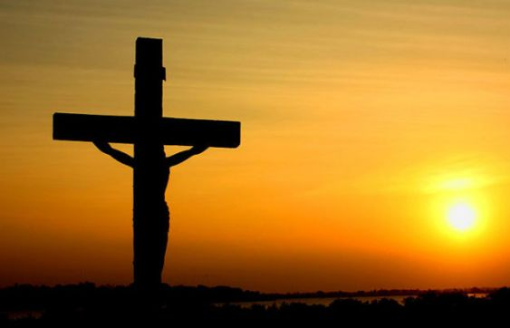
Christ came to save sinners
Here is a trustworthy saying that deserves full acceptance: Christ Jesus came into the world to save sinners—of whom I am the worst. (Timothy 1:15)

Whether we were the least or the worst of sinners, Jesus came for all of us. Jesus did not have to come, to live the life of a poor servant, beaten, persecuted and crucified but He did. He loves us too much to let us suffer on our own. He came to relieve us. He lived a just life and died an unjust death. In resurrection, He became the atonement sacrifice, and ransom, a victor. He conquered sin and death.

Christ’s accomplishment for us
“... and all are justified freely by his grace through the redemption that came by Christ Jesus. God presented Christ as a sacrifice of atonement, through the shedding of his blood—to be received by faith. He did this to demonstrate his righteousness, because in his forbearance he had left the sins committed beforehand unpunished — he did it to demonstrate his righteousness at the present time, so as to be just and the one who justifies those who have faith in Jesus. (Romans 3:24-26)
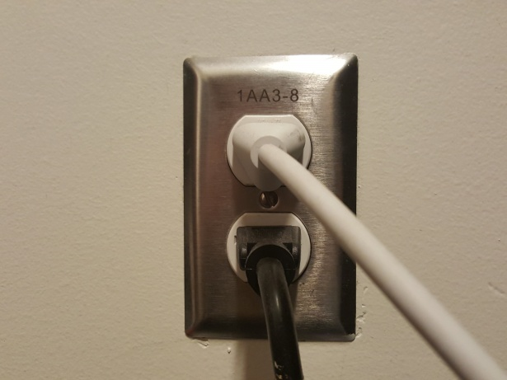
God justified those who have faith in Jesus. We were made right with God.

What we cannot do for ourselves, Christ accomplished for us by His life and His death. When there was no way, He made a way for us.

The opposite of sin is believing in God, so, be plugged back in Him. No matter how hard we try, may never be good enough, but God by His unconditionally love and mercy, sent Christ to earth to save us from eternal separation from Him.

We do not have to be good enough and we do not have to be because Christ is enough. What He has done is more than enough. There is nothing more for us to do, but to respond.

Responding to the Gospel
I have declared to both Jews and Greeks that they must turn to God in repentance and have faith in our Lord Jesus. (Romans 20:21)
We need to respond in repentance, and in faith.

Repent and Believe
Repent, then, and turn to God, so that your sins may be wiped out, that times of refreshing may come from the Lord, (Acts 3:19)
Repentance is making a 180° turn from what we are sorry for. It is the first response
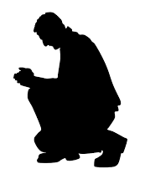
Sin is a rebellion against God and fighting the rightful king. The opposite is to ‘bend the knee to the king’ and to make a clear declaration, swearing an allegiance to the rightful king.

Life cannot be the same after that. We must yield to God’s authority. There should be real changes in our ways.

When we say sorry, there is only worldly sorrow. When we repent, there is a godly sorrow and brokenness in us. There will be a longing for that which is good.

First to those in Damascus, then to those in Jerusalem and in all Judea, and then to the Gentiles, I preached that they should repent and turn to God and demonstrate their repentance by their deeds. (Acts 26:20)

“Repentance, as we know, is basically not moaning and remorse, but turning and change.”
~J.I. Packer

With repentance, there will be a change of heart and a change of actions. It is a determination walk away from a sinful lifestyle and to put aside sinful thoughts and attitude.

Believe, Trust in God
They replied, “Believe in the Lord Jesus, and you will be saved—you and your household.” (Acts 16:31)

If you declare with your mouth, “Jesus is Lord,” and believe in your heart that God raised him from the dead, you will be saved. (Romans 10:9)

To trust, is to bet your life on it. When we have walked away from God, we walk into condemnation and destruction, but when we are confronted by the Gospel, we need to trust in what He says, and turn our direction back to Him.

Repentance and saving faith are inseparable.

“If we say, 'I believe in Jesus,' but it doesn't affect the way we live, the answer is not that now we need to add hard work to our faith so much as that we haven't truly understood or believed in Jesus at all.” ~Timothy Keller

“True repentance is no light matter. It is a thorough change of heart about sin, a change showing itself in godly sorrow and humiliation - in heartfelt confession before the throne of grace - in a complete breaking off from sinful habits, and an abiding hatred of all sin. Such repentance is the inseparable companion of saving faith in Christ.” ~J.C. Ryle

Conclusion
We pronounce the wonderful grace and love of God but if we do not tell people the need of repentance, that, is not saving faith. If we truly believe and recognize that sin destroys then, repentance is turning away from sin. Sin is the spoiler of our life.

God reached us to save sinners. It is faith in Christ and our repentance that saves us. When we know that we have sin, when we have a weak view, we need to repent.

Have we come to Christ? Do we know we were destined for eternal destiny that was disastrous and sin was the slippery path leading us into that destiny? Have we seen the gracious gift of God through Jesus Christ? Have we received that gift in your repentance and your saving grace?

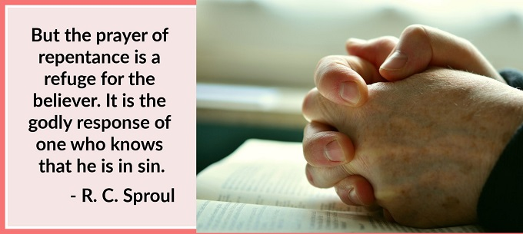

Sermon summary contributed Wendy ML.

