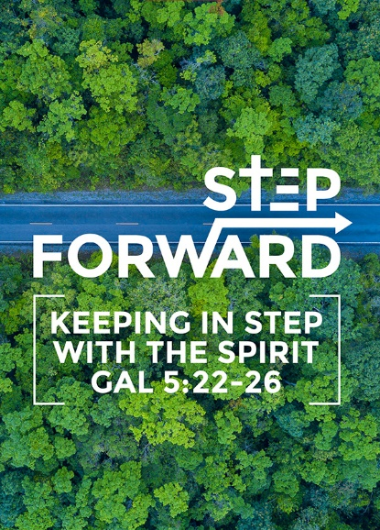
The Gospel 5: For Accountability
(Philippians 1:3-6, 2:12-13; Job 1:20-22)
Pastor Chris Kam

I thank my God every time I remember you. In all my prayers for all of you, I always pray with joy because of your partnership in the gospel from the first day until now, being confident of this, that he who began a good work in you will carry it on to completion until the day of Christ Jesus. (Philippians 1:3-6)

Therefore, my dear friends, as you have always obeyed—not only in my presence, but now much more in my absence—continue to work out your salvation with fear and trembling, for it is God who works in you to will and to act in order to fulfill his good purpose. (Philippians 2:12-13)

At this, Job got up and tore his robe and shaved his head. Then he fell to the ground in worship and said: “Naked I came from my mother’s womb, and naked I will depart. The Lord gave and he Lord has taken away; may the name of the Lord be praised.” In all this, Job did not sin by charging God with wrongdoing. (Job 1:20-22)

Introduction

The gospel takes you from the point of salvation until the end, namely the day we die. We are assured we are never left alone in the Christian faith.

We have been saved, we are being saved and we will be saved. This means that God saves us from ourselves and we should be transformed to be more like Jesus. When we die, we have victory in Christ. The gospel is the amazing good news that we have and we should tell others about this good news. The phrase “Order of Salvation” comes from the Latin “Ordo salutis”. We need to know what the gospel is in order to share with others.

Accountability means that we are accountable to God in our lives on Earth. When we become Christians, we belong to God and not ourselves.

So then, each of us will give an account of ourselves to God. (Rom 14:12)

This is not the judgment of salvation as we are already saved but this refers to the other judgment that is, the judgment of works where God will ask us to account for everything we have done on Earth.

“Look, I am coming soon! My reward is with me, and I will give to each person according to what they have done.” (Revelation 22:12)


We will be rewarded individually for what we have done. We are held accountable for what we do on this Earth. Therefore, we need to walk this journey well. As we serve God on Earth, God would take note. We serve Him wholeheartedly to please Him, not for the rewards. We need to ask ourselves if we can continue to walk in faith and finish our journey well. It is not by ourselves to do good works and impress God. We cannot impress God. We do good out of love for Him. Can we last the distance? Have we ever thought of giving up in following Christ? Many of us encounter certain points in our lives where we feel like giving up. There are many godly men in Scripture, like King David, who have felt the same way. It is normal for us as humans to struggle, especially in the midst of pain and suffering. When going through overwhelming circumstances, we need to remember that the gospel holds us to the end.


BIG IDEA: The Gospel holds you to the end

The Gospel holds us in God’s grace
I thank my God every time I remember you. In all my prayers for all of you, I always pray with joy because of your partnership in the gospel from the first day until now, being confident of this, that he who began a good work in you will carry it on to completion until the day of Christ Jesus. (Philippians 1:3-6)
The apostle Paul is confident of this truth. In the English Standard Version, the phrase is “I am sure of this” and in the New Living Translation “I am certain”. The original word is in the perfect tense, meaning something which is ongoing. God will carry it through for the Philippian Christians. God will complete what he starts in us.

We can go to extremes in our Christian life. We think that we work hard i.e. via doing good works to be accepted by God (this is not true because we live by grace). This belief can be influenced by our cultural or family background. However, good works should be a result of what God has done in our lives, not the means of acceptance. We do what we do because God loves us.

The Gospel holds us in our perseverance

Therefore, my dear friends, as you have always obeyed - not only in my presence, but now much more in my absence - continue to work out your salvation with fear and trembling, for it is God who works in you to will and to act in order to fulfill his good purpose. (Philippians 2:12-13)


We cannot save ourselves. We can only be saved by grace. We do not work for our salvation, but we work out our salvation. This means that after we are saved, we need to be serious about the Christian faith because God paid a high price for us and we need to respond back to God because of love. We need to produce fruit in our lives in keeping with repentance. This is not easy because we have the old nature in us. We need to God to deliver us from ourselves. The Bible never says it is an easy journey but often encourages us to persevere in the process of sanctification to be more like Jesus.

The other extreme is doing nothing and taking life easy since we have already been saved. An analogy is complacency setting in after marriage. We must remember that we made the choice to follow Jesus.

Verse 12 may appear like a self-help thing, but if we take verse 13 by itself, we may get the idea of spiritual lethargy since God will do everything. Hence, we should quote both verses together. This means we must work together with God. God does His part and we must also do our part. God’s part is conforming and transforming us into Christlikeness. Our role is in the arena of faith. We need to learn to walk by faith. We must be prepared to learn to trust God.

And without faith, it is impossible to please God … (Hebrews 11:6a)

If you love me, keep my commands. (John 14:15)

We need faith in our lives, and we need to obey Him. If we love God, we need to keep his commands. The gospel must change our lives.

There will be a beautiful synergy in our lives as we walk towards glorification.

We need to test ourselves to see if we are in the faith. This test is the fruit in our lives. Are we Christlike or has there been no change? We need to be real and authentic in our faith.

Examine yourselves to see whether you are in the faith; test yourselves. Do you not realise that Christ Jesus is in you - unless, of course, you fail the test? (2 Corinthians 13:5)

The Gospel holds us in our pain

The journey of faith is a painful journey.

In this world you will have trouble. But take heart! I have overcome the world. (John 16:33)

The Bible is full of words like “encourage”, “hold on”, “persevere” and “be courageous”. We need the church to shout words of encouragement to one another, especially as we go through pain in our lives. We need to walk together as a family. That is how God holds us together in our pain. We are never alone.

We can also deal with unanswered prayer, according to how we pray and how we wish our prayer will be answered. There are things in our lives which will tempt us to fall away from God. In Job, Satan’s argument is that faith depends on circumstance. If circumstance is good, worship goes up and if circumstance is bad, worship goes down. Even Job’s wife told him to forget about God. Job lost his servants, $25 million worth of livestock, 7 sons and 3 daughters. From Job’s life, we learn that there is nothing like suffering to reveal what is really inside. When we suffer, can we hold on to Christ as Christ holds on to us? When we confront pain, we are either pushed away from God or pushed deeper into God. Job grieved these tragic events and did not deny his sadness. However, he did not cease to worship his faithful God. He asked hard questions but held on to the belief that there is divine intentionality in everything he had gone through. God did not explain Himself to Job. Job did not get an answer. At the end of the book, God prospered Job again and gave him back his children.

At this, Job got up and tore his robe and shaved his head. Then he fell to the ground in worship
and said: “Naked I came from my mother’s womb, and naked I will depart. The LORD gave and the LORD has taken away; may the name of the LORD be praised.” In all this, Job did not sin by charging God with wrongdoing. (Job 1:20-22)

All his brothers and sisters and everyone who had known him before came and ate with him in his house. They comforted and consoled him over all the trouble the LORD had brought on him, and each one gave him a piece of silver and a gold ring. (Job 42:11)

Suffering can come from God. God can allow circumstance to happen in our lives. God is sovereign but our part is faith. We need to think of the endpoint, which is glorification i.e. eternity in Christ Jesus.

But he said to me, “My grace is sufficient for you, for my power is made perfect in weakness.” Therefore I will boast all the more gladly about my weaknesses, so that Christ’s power may rest on me. (2 Corinthians 12:9)

We need to walk in faith.

David Watson was one of the best known and loved Christian leaders of modern times… he had an impact as evangelist and teacher second only to Billy Graham. (Michael Green)


At 50 years old, David Watson wrote his book entitled “Fear No Evil” describing his battle with colon cancer which had spread to his liver. He described his faith and how he sought healing. He initially met his diagnosis with disbelief, and he expressed fear, not of death, but of the process of dying. He had encountered other people with cancer who had experienced pain. Two months before he died, he flew to California to be prayed for by a team of people well-versed in healing but his condition continued to deteriorate. He returned to the United Kingdom. He was challenged to seek God’s face and he experienced God’s perfect love which casts out all fear. He eventually passed away peacefully. The book ends with the phrase “the Lord reigns”.

What will our faith be like if we have to go through difficult times?

Conclusion

God holds us to the end as we walk this journey.

Shortly before he died David Watson wrote the following: “The most important lesson I have learned in these past eleven months is that God loves me, is always with me – in the dark as in the light – and that I cannot trust him too much. The best is yet to be, once we have put our lives in Christ.”

Sally, a DUMC member, also shared her testimony in DUMC Stories (https://youtu.be/RonlWJLlKZQ). When she lost her husband, she could either get angry with God or turn to Him. It was challenging to bring up four children singlehandedly, but God is faithful. God’s community also offered support to help her family. God is faithful and reminded her that He will be with their family in the future. He also assured her that her husband is with God and one day, they will be together in heaven.

We need to live the gospel life so that as we can model to others that we can go through pain and grieve with hope. God understands the pain that we go through. We need to go to Jesus and the good news of the gospel. As we surrender whatever we go through to God, the journey of faith makes us more Christlike. We may not have answers as to why things happen to us but we need to trust in God and ask Him for help.

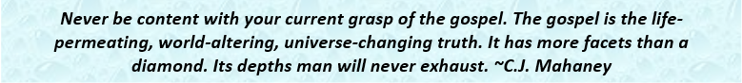

Sermon summary by Zhenli

