
The 3Ms of Sticky Marriage: The Mission of Marriage
(John 15:5-8; Philippians 4:11b-13; Ephesians 5:31-32)
Senior Pastor Chris Kam

“I am the vine; you are the branches. If you remain in me and I in you, you will bear much fruit; apart from me you can do nothing. If you do not remain in me, you are like a branch that is thrown away and withers; such branches are picked up, thrown into the fire and burned. If you remain in me and my words remain in you, ask whatever you wish, and it will be done for you. This is to my Father’s glory, that you bear much fruit, showing yourselves to be my disciples. (John 15:5-8)

I am not saying this because I am in need, for I have learned to be content whatever the circumstances. I know what it is to be in need, and I know what it is to have plenty. I have learned the secret of being content in any and every situation, whether well fed or hungry, whether living in plenty or in want. I can do all this through him who gives me strength (Phil 4:11-13)

“For this reason a man will leave his father and mother and be united to his wife, and the two will become one flesh.” This is a profound mystery—but I am talking about Christ and the church. (Ephesians 5:31-32)

Introduction
The sermon series started last week with The Myths of Marriage. The big idea was to “Marriage is not just about you. It is more about Christ and His Church, and you becoming more like Him”. We are reminded of the 3 myths:
- Myth #1: Growing deeper in marriage will come naturally.
- Myth #2: He or she will meet my deepest needs.
- Myth #3: It (Divorce) won’t happen to me.
What marriage is:
- Marriage is about meeting the needs of your spouse.
- Marriage is really hard work (Radical Discipleship).

This week, Pastor Chris goes into the Mission of Marriage.

The marriage of our parents shaped the way we are. The mission is for the greater good of the society, nation and the government. The pattern of sons becoming husband, fathers, and grandfathers is normal in marriage.


BIG IDEA: The Mission of Marriage is to grow disciples of Jesus.

A home of Demonstration (of Christ’s love for the church)
1+1=1. This is a mystery. It shows how Jesus Loves the church unconditionally and while we were still sinners. This selfless love is demonstrated in marriage.

Jesus replied, “Anyone who loves me will obey my teaching. My Father will love them, and we will come to them and make our home with them. Anyone who does not love me will not obey my teaching. These words you hear are not my own; they belong to the Father who sent me. (John 14:23-24)

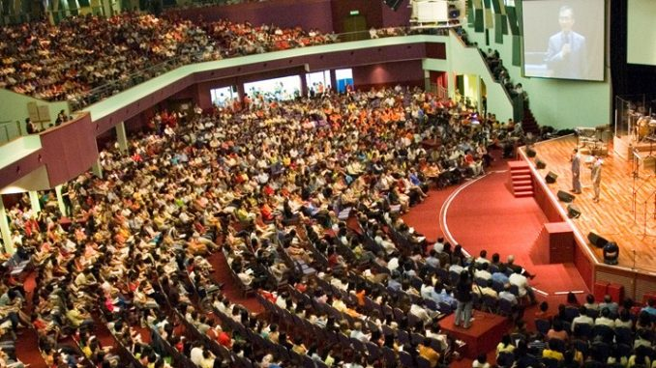
You cannot follow Jesus and cannot obey what he teaches. If you obey, we will come to you and make our home with them. “Our” refers to God the father and the Son Jesus Christ. This is the privilege of a Christian. The spirit dwells in us making the home in us. When God says “I will never leave you”, he stays forever. This is an amazing privilege.

The term home is “monen” in Greek. This refers to the singular noun where God dwells in our hearts.

In John 14:2 My fathers house has many rooms. The term room is “monai” in Greek. This refers to God’s eternal home in heaven.

It is advised that both husband and wife accept Christ before entering marriage. Once God dwells and people come together in marriage, we represent Christ’s church. Is our marriage representing Jesus?

The bottom line is after 20 years, are you a better disciple?

“If you want to get married, you must make sure your marriage will give you a greater love for the Lord, the things of the Lord, a greater prospect of ministry. If not stay single.” ~ Josh McDowell

“For this reason a man will leave his father and mother and be united to his wife, and the two will become one flesh.” This is a profound mystery—but I am talking about Christ and the church. (Ephesians 5:31-32)

2.0 A Home for Discipleship (Multiplication)

Two most important life decisions:
1. Decision 1: Who will be your master?
2. Decision 2: Who will be your mate? This is the person you will spend the rest of your life

We should ask, “God, do you want me to get married?” Celibacy is a gift from God.

2.1 Celibacy


Your contentment is fulfilled in Christ. Singleness is not a short-change in life. Contentment is found in Jesus, not in your marital status.

Some are born as eunuchs, some have been made eunuchs by others, and some choose not to marry for the sake of the Kingdom of Heaven. Let anyone accept this who can. (Matthew 19:12, NLT)

There are people who choose to be single because they will be focused on what God has called them to do. Their focus in heaven. The desire is there but they do not want marriage to get in the way. We need to come along and encourage people like this.

This is Pauls opinion. He chose celibacy as a gift God has given so that he can focus.

I say this as a concession, not as a command. I wish that all of you were as I am. But each of you has your own gift from God; one has this gift, another has that. (1 Corinthians 7:6-7)

By being married, your interests are divided. This is why Paul encourages people to stay single. The crux of the matter is that you stay focused in the Lord by giving your undivided devotion.

I would like you to be free from concern. An unmarried man is concerned about the Lord’s affairs—how he can please the Lord. But a married man is concerned about the affairs of this world—how he can please his wife— and his interests are divided. An unmarried woman or virgin is concerned about the Lord’s affairs: Her aim is to be devoted to the Lord in both body and spirit. But a married woman is concerned about the affairs of this world—how she can please her husband. I am saying this for your own good, not to restrict you, but that you may live in a right way in undivided devotion to the Lord. (1 Corinthians 7:32-35)

Whatever station in life, the point is undivided devotion to the Lord.

2.2 Contentment with Christ

“I am the vine; you are the branches. If you remain in me and I in you, you will bear much fruit; apart from me you can do nothing. If you do not remain in me, you are like a branch that is thrown away and withers; such branches are picked up, thrown into the fire and burned. If you remain in me and my words remain in you, ask whatever you wish, and it will be done for you. This is to my Father’s glory, that you bear much fruit, showing yourselves to be my disciples. (John 15:5-8)

Paul has found the secret of being content. Men are attracted to physical looks and women look for emotions. As we grow older, we lose our physics and emotionally. We should be spiritual attracted and Christlikeness in the person. Do your marriage a favour by growing in Christ. It is not about looks and personality but by growing in Christ, we become more attracted to each other.

I am not saying this because I am in need, for I have learned to be content whatever the circumstances. I know what it is to be in need, and I know what it is to have plenty. I have learned the secret of being content in any and every situation, whether well fed or hungry, whether living in plenty or in want. I can do all this through him who gives me strength. (Philippians 4:11-13)

We can participate with Christ
Through these he has given us his very great and precious promises, so that through them you may participate in the divine nature, having escaped the corruption in the world caused by evil desires. (2 Peter 1:4)

We may be wasting outwardly but inwardly we are growing. We should grow in Christ, make this our highest priority. We need to encourage our spouse towards Christlikeness. Our children are our first disciples.

Therefore, we do not lose heart. Though outwardly we are wasting away, yet inwardly we are being renewed day by day. (2 Corinthians 4:16)

“I want my wife to know that I will love her the way God wants me to, and I want her to express to the fullest potential and giftedness in serving God.
I want my children to see that their dad loves God dearly and serves Him joyfully, and they would want to have what dad has. I want to see my children grow up in the Lord and serve him wholeheartedly.” ~Pastor Chris’s Vision

3. A home of destiny for God’s Kingdom.

“I am the God of Abraham, Isaac and Jacob.” God is a god of multi generations. The challenge of a marriage is the 4th generation.

3.1 Parents / grandparents
They must say that the choice of spouse is very important. You need to marry well. Teach them to Love God and Serve God and Make Disciples.

3.2 Courting couples
Be Mr. or Ms. Right before looking for the other. Mothers should take their sons out and teach them how to treat women. Model the spirituality above the physical or financial attributes. Agree early that children check with the parents. Your parents know more than you think.

3.3 Children
The Holy Spirit in your children is the same Holy Spirit in you. The parents need to disciple children. What is the legacy you are leaving behind? What disciples are you leaving behind?

As God asks you to chase the lion. What is the legacy you are leaving behind?

Conclusion

We are called to chase lions. What is the legacy are you leaving behind?



Sermon summary by Abbey.

