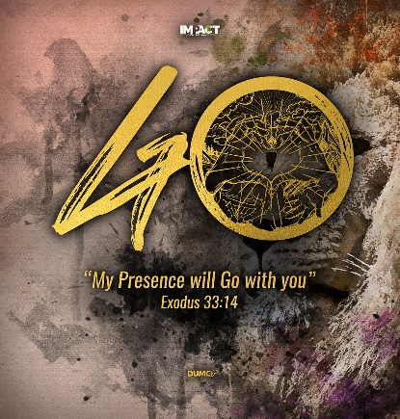
The Apostles’ Creed
I Believe In
(James 2:14-19, Ephesians 3:17b-19)
Senior Pastor Chris Kam

What good is it, my brothers and sisters, if someone claims to have faith but has no deeds? Can such faith save them? Suppose a brother or a sister is without clothes and daily food. If one of you says to them, “Go in peace; keep warm and well fed,” but does nothing about their physical needs, what good is it? In the same way, faith by itself, if it is not accompanied by action, is dead. But someone will say, “You have faith; I have deeds.” Show me your faith without deeds, and I will show you my faith by my deeds. You believe that there is one God. Good! Even the demons believe that—and shudder. (James 2:14-19)

And I pray that you, being rooted and established in love, may have power, together with all the Lord’s holy people, to grasp how wide and long and high and deep is the love of Christ, and to know this love that surpasses knowledge—that you may be filled to the measure of all the fullness of God. (Ephesians 3:17b-19)

Introduction

What do you believe in? Are you able to articulate what you believe in? Why is our belief so important? Our belief shapes our behaviour. Right belief will result in the right behaviour. Wrong belief will result in a wrong behaviour. For example, if you think money and career are the most important things in life, it will determine your lifestyle and priorities. You will do all you can and neglect your family and spiritual life. If you think you are the most important person in life, then you will become a self-centred person.

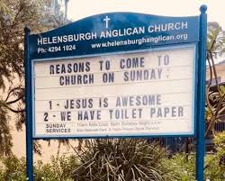
Crisis has a way of revealing who we are. For instance, the panic-buying during this Covid-19 pandemic reveals your underlying belief system. Psychologically, these people think they are important and that they need to take care of themselves. These people need to put in a measure of self-control. Our underlying belief system is the way we cope with life. A church in New South Wales, Australia, has posted this in front of their church in response to all the panic-buying:

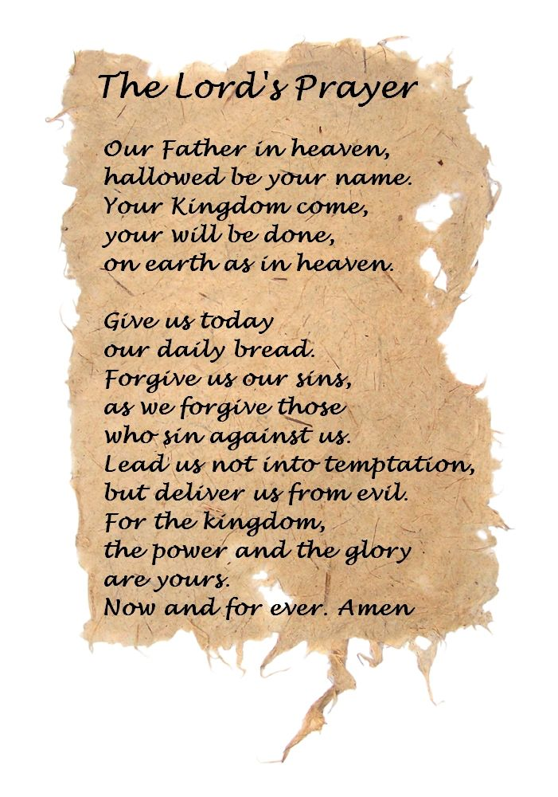
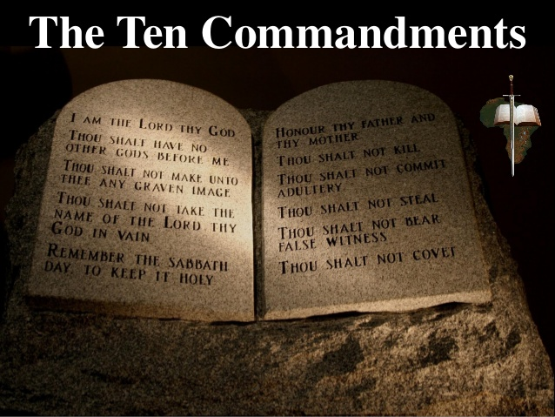
Our belief system helps us cope with life, whether rightly or wrongly. It helps makes decisions, whether rightly or wrongly. It also determines the priorities in life. Our belief system helps us lead our lives. Are we clear as to what we belief as Christians? The Ten Commandments is a moral law that exist until today. The Lord’s Prayer is something that the Lord taught us how to pray.

The Apostles’ Creed came about in the first 200 years of the early Christian life. It started through the baptism of new believers as they met in houses. In the early years, prior to being baptised, they will be asked certain questions; for example, do you believe in God the Father, God the Son and God the Holy Spirit? Over time, this was developed into a creed. The Apostles’ Creed was developed for the baptism of the early Christians. There are three other main creeds: Nicene Creed (AD 325, 381), Chalcedonian Creed (AD 451) and Althanasian Creed (ca. AD 500).

The word ‘creed’ comes from the Latin word ‘credo’, which means ‘I believe’. The Apostles’ Creed is a summary of what the apostles were teaching and their faith as early Christians.

Two main purposes of The Creed:

- Educational
It instructs the believer. To become a Christian, one would need to recite the Apostles’ Creed to show that this is what they believe in. It is foundational to their faith. However, it does not replace Bible-reading nor the study of God’s Word. It also helps to align with the truth of the Bible, and correct any errors that you may have.

The believers began to realise that there are differences in beliefs among themselves that are minor, that they can agree to disagree. For example, in the area of the style of worship, baptism etc. However, there are areas where believers cannot choose to agree to disagree. For example, in the area of the Virgin Birth, the Divinity of Christ and the Resurrection of Christ.

- Sacramental
For the early Christians, the Apostles’ Creed was used as a liturgy, something that they recite before they get baptised. For instance, before getting baptised, the believer will be asked the following question: Do you believe in God, the Father Almighty, maker of heaven and earth, and in Jesus Christ His only Son our Lord; an in the Holy Spirit, the Lord, the Giver of life?


BIG IDEA
You are what you believe

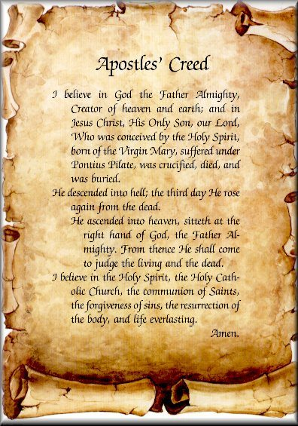
If you do not have the right belief, then it will affect your behaviour in a wrong way. It can bring the best out of you, or the worst out of you.

THE APOSTLES’ CREED

I Believe in God, the Father Almighty,
Creator of heaven and earth,

I Believe in Jesus Christ, His Only Son, our Lord,
who was conceived by the Holy Spirit,
born of the Virgin Mary,
suffered under Pontius Pilate,
was crucified, died, and was buried;
the third day He rose again from the dead.
He ascended into heaven,
is seated at the right hand of the Father,
and will come again to judge the living and the dead.

I Believe in The Holy Spirit,
the holy catholic* church,
the communion of saints,
the forgiveness of sins,
the resurrection of the body,
and the life everlasting.
Amen.
*universal

The Apostles’ Creed starts with ‘I believe in’.

I
It starts with you. Our belief in God starts with you. No one can believe for you. We must make up our own mind. It starts with the truth that you believe in, not a subjective conviction. But it is a confusing world that we live in, because the world says I have the right to choose what I believe in, or what I think is right. Hence, the term ‘relativism’, where everything is relative. But the disciples of Jesus Christ choose to believe not in their subjective understanding, but in the master Jesus Christ. You need to believe in God yourself; no one can believe it for you. It is a personal decision.

This ‘I’ is more than one single person. This ‘I’ is actually the church as well. It is the community of God’s people drawing together by their common faith in Jesus Christ. The Apostles’ Creed hold the fundamental belief of the Christian faith. We do not believe alone; we believe together as the body of Christ, bound by the Word of God.

Believe
There is a difference between knowing and believing. A wife may say to the husband, ‘I know you love me but do I believe it?’ What the person is saying is, ‘do I trust in what you are saying?’ Believe is more than knowing; it is trust.

You believe that there is one God. Good! Even the demons believe that—and shudder. (James 2:19)

The demons do not trust God, but we do. God is going to change many things in our lives as we trust in Him. God will clean up our minds over time. We need to read the Bible everyday so that it will change the way we believe.

The bad things in life reveal who we are. They are not necessarily bad; they build us up in our faith, when we allow the Word of God to change the way we believe.

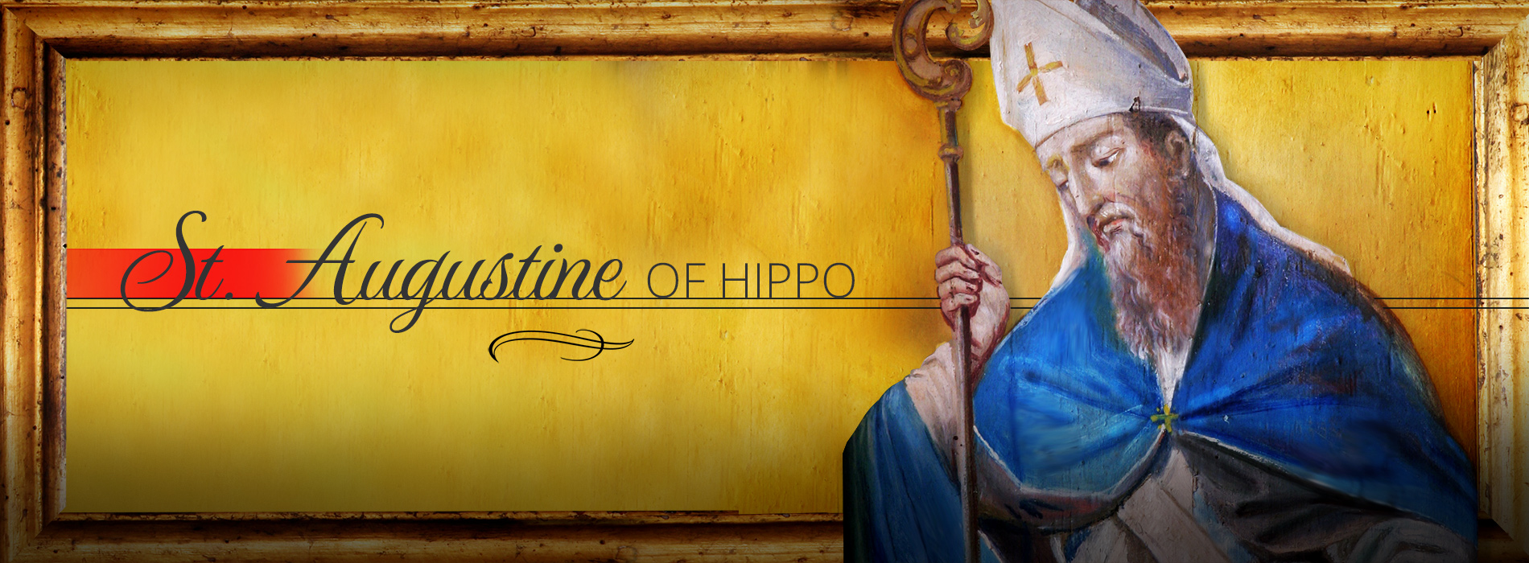
Do not be anxious about anything, but in every situation, by prayer and petition, with thanksgiving, present your requests to God. (Philippians 4:6)

“If you can’t understand, believe, and then you’ll understand” – Saint Augustine of Hippo

Believe is to trust. We may not fully understand everything in life, but we must be prepared to trust Him. We walk the journey with this God that we believe in. He will prove to us that He is really good.

“Taste and see that the Lord is good,” (Psalms 34:8)

Believing and trusting is not a one-off thing. It is on-going throughout our lives. Trust is living out in action of what we believe in.

In

We can say that ‘we believe’, but what do we believe in? When he was young, Pastor Chris believed that a plank that straddles a drain could take the weight of him and his bicycle, but it could not, and he broke his arm as a result of crossing on the plank.

It is very important that we know what we believe in.
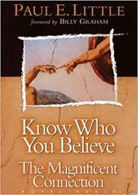
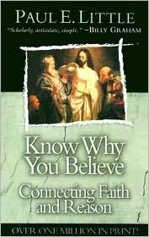
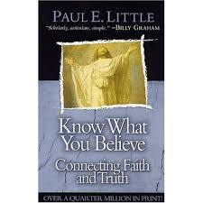

Paul E. Little first wrote ‘Know What You Believe’, which was followed by ‘Know Why You Believe’ and finally, he wrote ‘Know Who You Believe’.

That is why I am suffering as I am. Yet this is no cause for shame, because I know whom I have believed, and am convinced that he is able to guard what I have entrusted to him until that day. (2 Timothy 1:12)

It is a person that you are following, not some set of teaching that you are following.

Do you know the person Jesus Christ?

It is not the amount of faith that you have. If you have the faith of a mustard seed, you can move mountains. It is not the size of your faith.

It is the object of your faith – Who you believe in. Our Christian faith is anchored upon Who we believe in.

And I pray that you, being rooted and established in love, may have power, together with all the Lord’s holy people, to grasp how wide and long and high and deep is the love of Christ, and to know this love that surpasses knowledge—that you may be filled to the measure of all the fullness of God. (Ephesians 3:17b-19)

In the same way, faith by itself, if it is not accompanied by action, is dead. (James 2:17)

It is about doing what we say we believe in. We must demonstrate the changed life. Some non-believers are turned off by the behavior and hypocrisy of Christians. That is why when we say we believe in Christ, we must change our behavior.

Conclusion
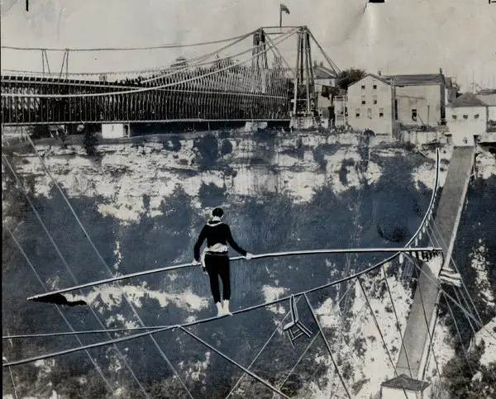


Charles Blondin was a French tightrope walker. He was known for crossing the 1,100 feet Niagara Gorge on a tightrope, and doing various stunts while walking on the tightrope. One of his stunts include wheeling a person on a wheelbarrow on the tightrope.

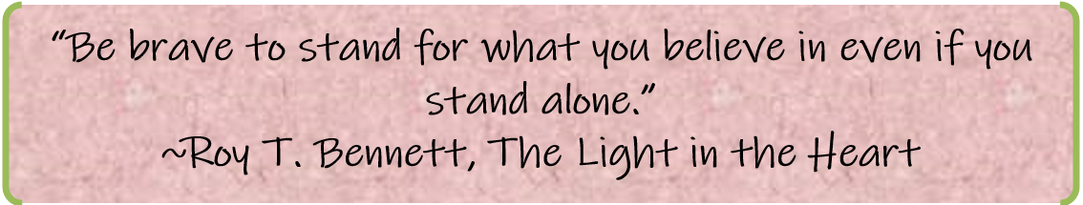

If you believe in the person Jesus Christ, would you trust your life in Him? Believing and trusting your life in Him means putting yourself on the wheelbarrow.

It is time for us to examine and reflect on Who we believe in. He is in control, can we trust Him?

Sermon summary contributed by May

